*Florida International University*

*School of Computing and Information Sciences*

Software Engineering Focus

Final Deliverable

Project Title: Betwixt 1.0

**Team Members:** Alicia Rodriguez, Daniel Raad, & Alejandro Palacios

**Product Owner(s)**: Joseph Cutrono

**Mentor(s)**: Joseph Cutrono

**Instructor**: Masoud Sadjadi

The MIT License (MIT)

Copyright (c) *2016 Florida International University*

Permission is hereby granted, free of charge, to any person obtaining a copy of this software and associated documentation files (the "Software"), to deal in the Software without restriction, including without limitation the rights to use, copy, modify, merge, publish, distribute, sublicense, and/or sell copies of the Software, and to permit persons to whom the Software is furnished to do so, subject to the following conditions:

The above copyright notice and this permission notice shall be included in all copies or substantial portions of the Software.

THE SOFTWARE IS PROVIDED "AS IS", WITHOUT WARRANTY OF ANY KIND, EXPRESS OR IMPLIED, INCLUDING BUT NOT LIMITED TO THE WARRANTIES OF MERCHANTABILITY, FITNESS FOR A PARTICULAR PURPOSE AND NONINFRINGEMENT. IN NO EVENT SHALL THE AUTHORS OR COPYRIGHT HOLDERS BE LIABLE FOR ANY CLAIM, DAMAGES OR OTHER LIABILITY, WHETHER IN AN ACTION OF CONTRACT, TORT OR OTHERWISE, ARISING FROM, OUT OF OR IN CONNECTION WITH THE SOFTWARE OR THE USE OR OTHER DEALINGS IN THE SOFTWARE.

***Abstract***

*This document presents the information necessary to gain a good understanding of the introduction of the Betwixt mobile application, the user stories in order to develop the Betwixt mobile application, the project plan, system design, and system validation.*

*Betwixt is an iOS and Android mobile application that calculates the central location between users and suggests locations to meet up around that central location.*

**Table of Contents**

**Introduction** …………………………………………………………………………………………….....6

Current System ……….…………………………………………………………………………………………………..6

**User Stories**

Implemented User Stories ………………………………………….…………………………………..7

Pending User Stories …………………………………………………………………...…………………………………. 110

**Project Plan**

Hardware and Software Resources ……………………………………………………………….… 111

Sprints Plan ……………………………………………………………..…………………………………………………… 112

*Sprint 1*  ………………………………………………………………………………………………………………………..112

*Sprint 2*  ………………………………………………………………………………………………………………………..113

*Sprint 3* ………………………………………………………………………………………………………………………....114

*Sprint 4*  ………………………………………………………………………………………………………………………...115

*Sprint 5*  ………………………………………………………………………………………………………………………. 116

*Sprint 6*  ………………………………………………………………………………………………………………………..117

**System Design**

Architectural Patterns ………………………………………………………………………………………………….. 118

System and Subsystem Decomposition …………………………………………………………………………….… 119

Deployment Diagram …………………………………………………………………………………………………….…... 120

Design Patterns ………………………………………………………………………………………………………….….... 120

**System Validation**  …………………………………………………………………………………………………………………….121

**Glossary**  ………………………………………………………………………………………………………………………………….123

**Appendix**  ………………………………………………………………………………………………………………………………….124

Appendix A - UML Diagrams …………………………………………………………………………………………………..124

Appendix B - User Interface Design …………………………………………………………………………….…... 146

Appendix C - Sprint Review Reports …………………………………………………………………………...…… 146

Appendix D - User Manuals, Installation/Maintenance Document, Shortcomings/Wishlist Document and other documents …………………………………………………………………….…………… 150-151

# 

# 

# 

# Introduction

Betwixt stands to be a solution for virtual employees and their coworkers to find a central location to meet up at to work from. The main focus of Betwixt is to provide its user an easy to use and fun way to find a location to meet up that’s in the middle of everyone. Betwixt aims to make it easier for everyone to find a location to meet up at, unlike other solutions that just give me suggestions of locations.

## 

## Current System

The current system consists of an iOS and Android mobile application which simplifies the process of finding a location to meet up for a large group of people. It will calculate the central location between users and then the the admin user will be able to select a location to meet up at that is close to the central location. The server is relatively light and primarily acts as a way to communicate data between clients. For example, when a user joins the group, the user send its location via a Socket.IO connection to other users with the server as an intermediary. The other users receive the data and send their data to the server, which in turn sends it to the specific user that joins the group.

# 

# User Stories

The following section provides the detailed user stories that were implemented in this iteration of the Betwixt project. These user stories served as the basis for the implementation of the project’s features. This section also shows the user stories that are to be considered for future development.

## Implemented User Stories

**User Story Name: Get Locations Around you**

* Description: As a user I would like to see pins drop on recommended locations around me to meet up once the app loads and gets my location.

Acceptance Criteria

* Call the workfrom.co api to retrieve recommended locations around my current location
* Drop pins on locations retrieved from workfrom.co api around my current location

**Use Case**

* Name: View recommended locations around you
* Actor: A virtual employee
* Preconditions: Actor has opened app and allowed geolocation services
* Description <Flow of events>:

1. Actor opens app
2. Actor is prompted to allow access to their geolocation
3. Actor’s location and recommended meet up location are placed on the map

**Use Case Diagram**

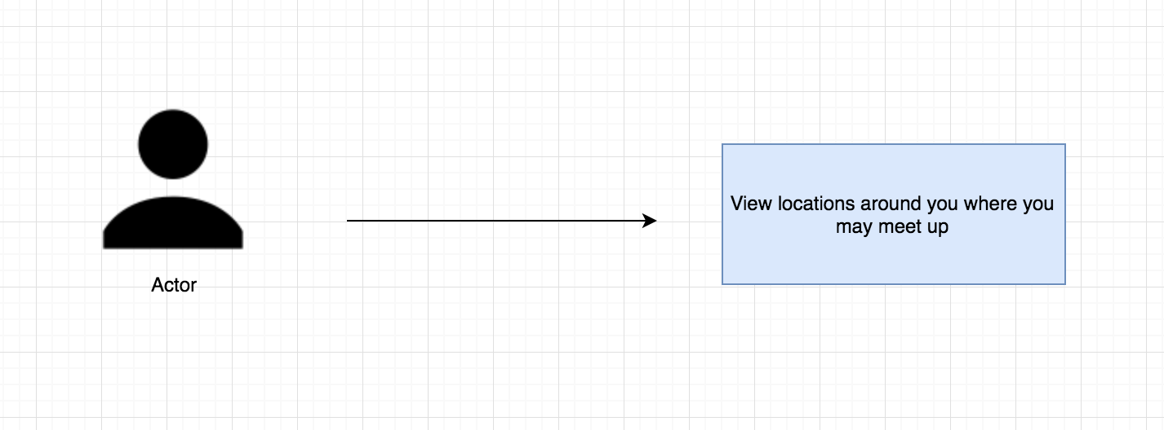

**Sequence Diagram**

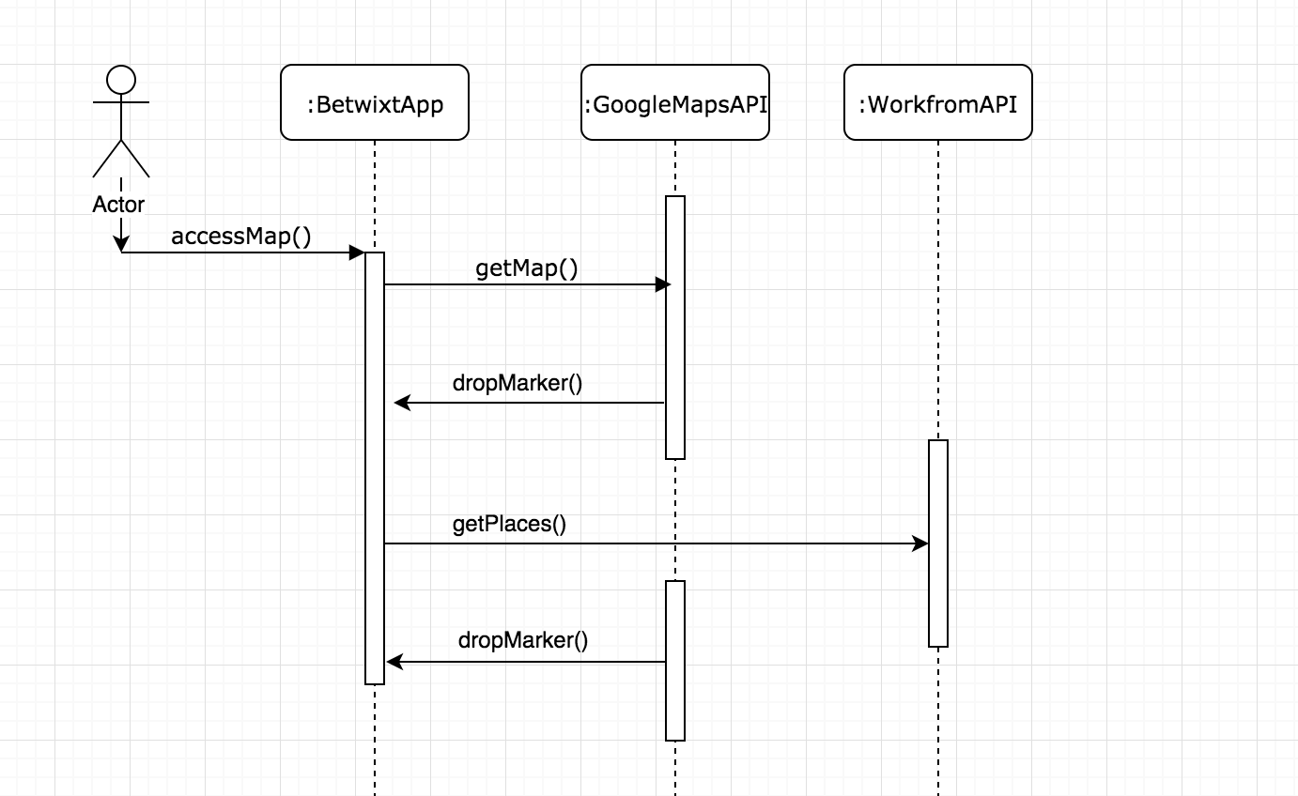

**Class Diagram**

N/A

**Unit Test**

* Test case ID: 001
* Description/Summary of Test: Display locations around the actor.
* Pre-condition: The actor gives geolocation access to the application.
* Expected Results: The Workform api will be called and locations will be displayed to the actor.
* Actual Result: The api was hit successfully and pins were dropped on the locations.
* Status (Fail/Pass): Pass

**Visual User Guide**

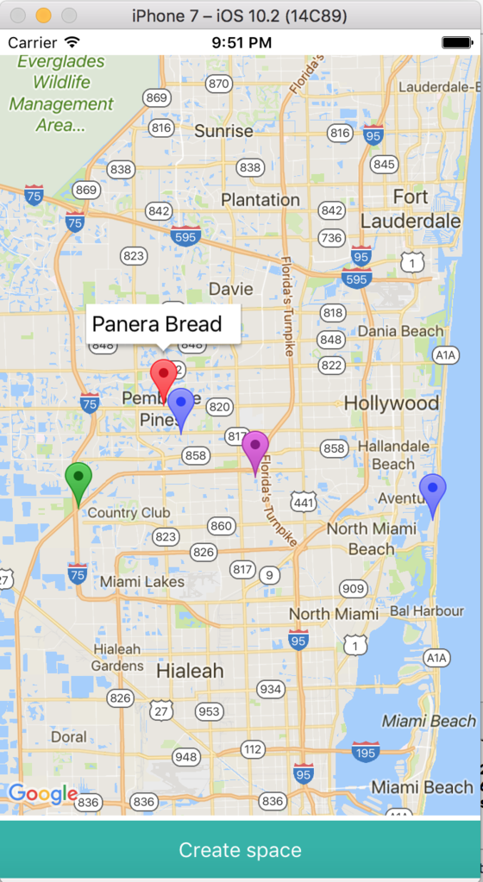

**User Story Name: Initial Map View**

* Description: As a user, I would like to have a map view displaying my location so that I can see locations around me.

Acceptance Criteria

* The map displays the user’s location properly.
* You are allowed to navigate through the map.

**Use Case**

* Name:
* Actor:
* Preconditions:
* Description <Flow of events>:

**Use Case Diagram <**you can use draw.io**>**

**Sequence Diagram**

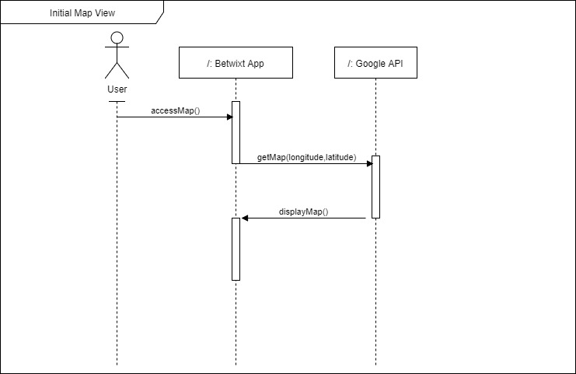

**Class Diagram**

**Unit Test**

* Test case ID:
* Description/Summary of Test:
* Pre-condition:
* Expected Results:
* Actual Result:
* Status (Fail/Pass):

**Integration Test**

**Visual User Guide** <like one or two screenshots of the feature. For the hardware project, a photo of device is required>

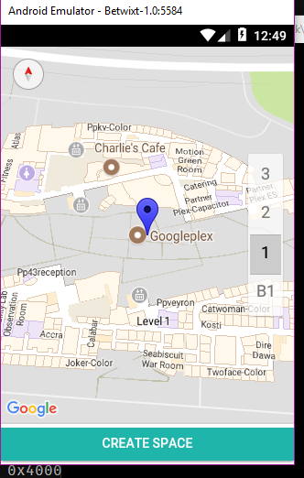

**User Story Name: Display Central Location**

* Description: As a user, I want to get the central location between myself and at least 2 other locations, so that I can see what the central location will be.

Acceptance Criteria

* Show pins on the map of each of the locations that are retrieved
* Drop a pin on the central location that was calculated

**Use Case**

* Name: See Central Location
* Actor: A virtual employee
* Preconditions: Actor has opened the app on their phone
* Description:

1. Actor selects yes to allow the use of their current location.
2. App displays Actor’s current location displayed as a green pin.
3. App displays the other locations of their coworkers as a blue pin.
4. App displays the central location as a purple pin.

**Use Case Diagram**

[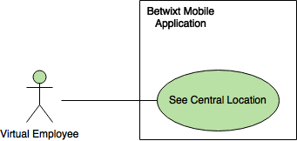](https://www.draw.io/#G0B5wDOQeZQxiaWkxremhOdnFwZ0k)

**Sequence Diagram**

[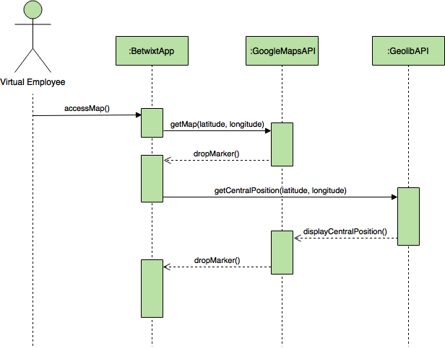](https://www.draw.io/#G0B5wDOQeZQxiaU09BTmJ5Rm1IZzQ)

**Class Diagram**

Not applicable.

**Unit Test**

* Test case ID: 001
* Description/Summary of Test: Display to the user the central location.
* Pre-condition: The user’s current location is available as well as other locations.
* Expected Results: To get the central location.
* Actual Result: The central location
* Status (Fail/Pass): Pass

**Visual User Guide**

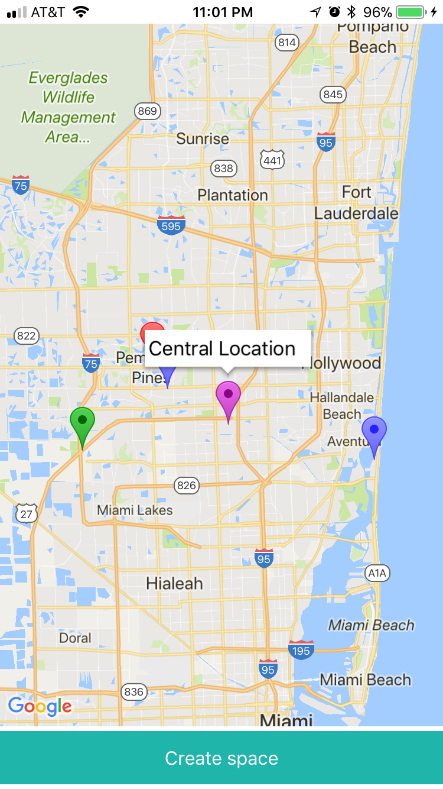

As described in the Use Case, the green pin shows the user’s current location, the blue pins are the locations of their coworkers, and the purple pin in the center, shows the central location.

**User Story Name: Joining a Group**

* Description: **As a** User **I would like** to be able to join a group **so that** other members can see my location and I could see theirs.

Acceptance Criteria

* When I click on a deep link, the app will open and will show other group member’s locations as pins on the map.

**Use Case**

* Name: Join Group
* Actor: User of the application
* Preconditions: They allow the app to use their geolocation
* Description <Flow of events>:

1. They receive a deep link from another user of the app.

2. They click the link to join the group.

3. They can see the other user’s locations as pins.

**Use Case Diagram <**you can use draw.io**>**

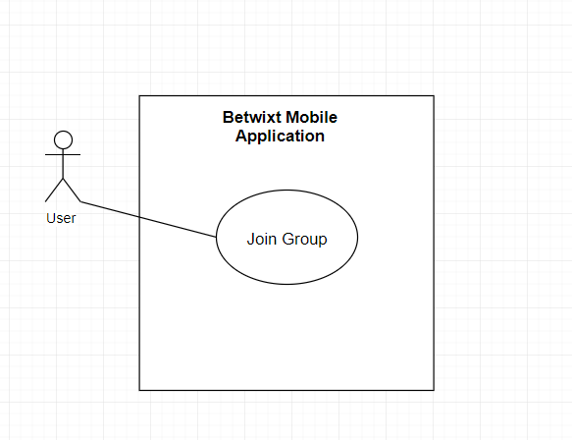

**Sequence Diagram**

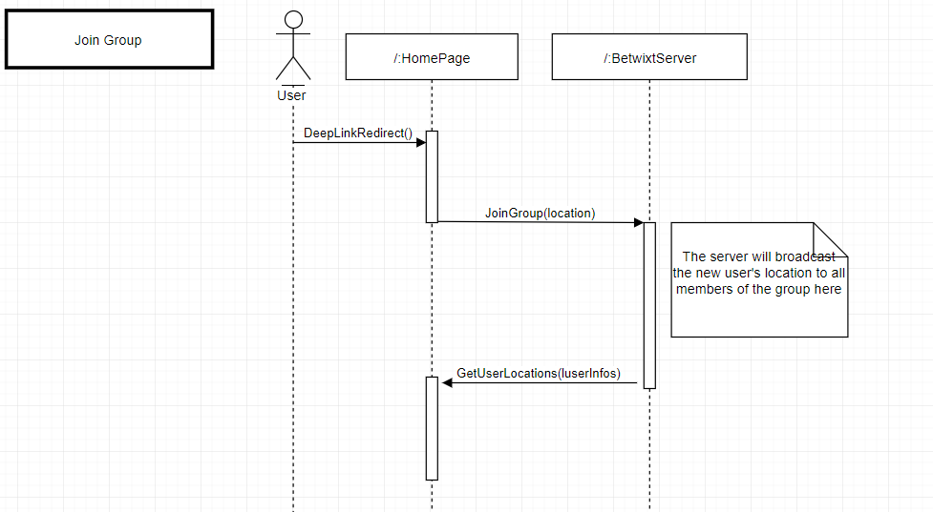

**Class Diagram**

N/A

**Visual User Guide** <like one or two screenshots of the feature. For the hardware project, a photo of device is required>

The android phone joined the group. We zoom in on the Apple phone and see there are 2 pins in the same location.

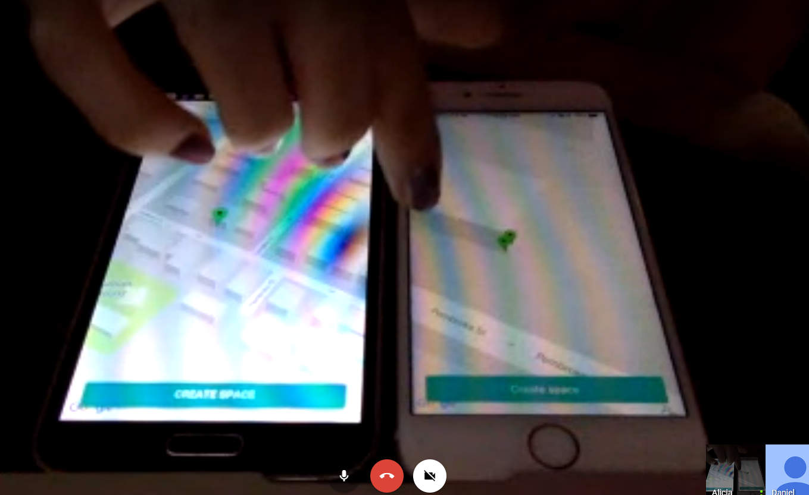

**User Story Name: [BUG] Deep Linking Causes Map To Disappear**

* Description: **As a** User **I would like** to be able to use deep linking **so that** the map does not disappear when I join another user’s group.

Acceptance Criteria

* When I click a deep link given to me by another user I should join their group without my map disappearing

**Use Case**

* Name: Working Case
* Actor: User of the application
* Preconditions: They allow the app to use their geolocation
* Description <Flow of events>:

1. They receive a deep link from another user of the app.

2. They click the link to join the group.

3. They successfully join and their map does not disappear.

**Use Case Diagram <**you can use draw.io**>**

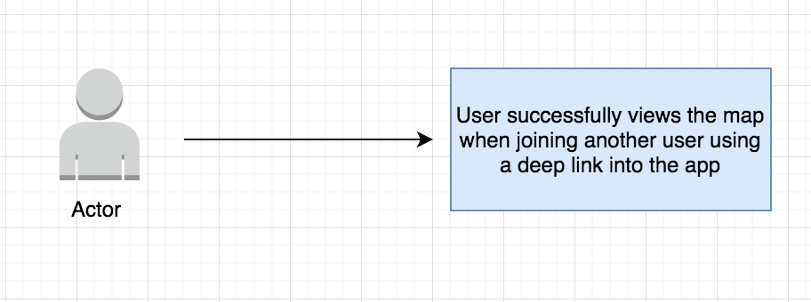

**Sequence Diagram**

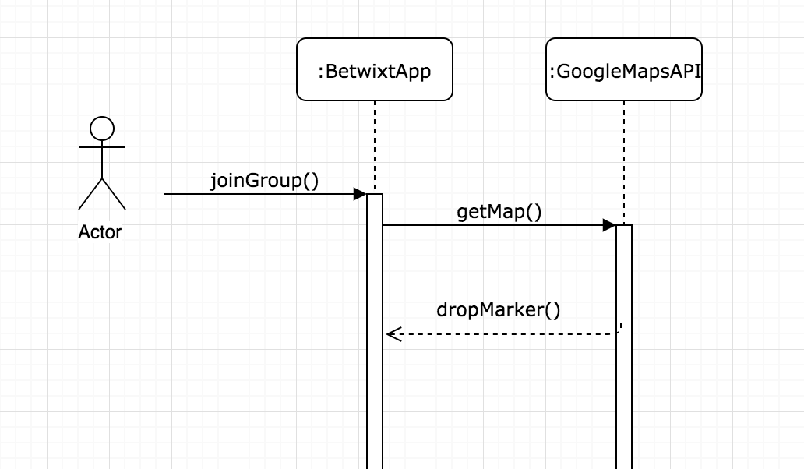

**Class Diagram**

N/A

**Visual User Guide** <like one or two screenshots of the feature. For the hardware project, a photo of device is required>

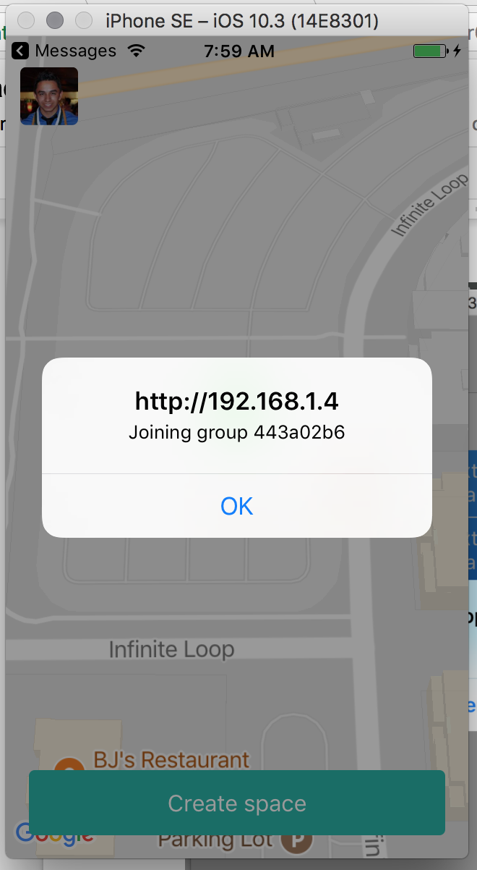

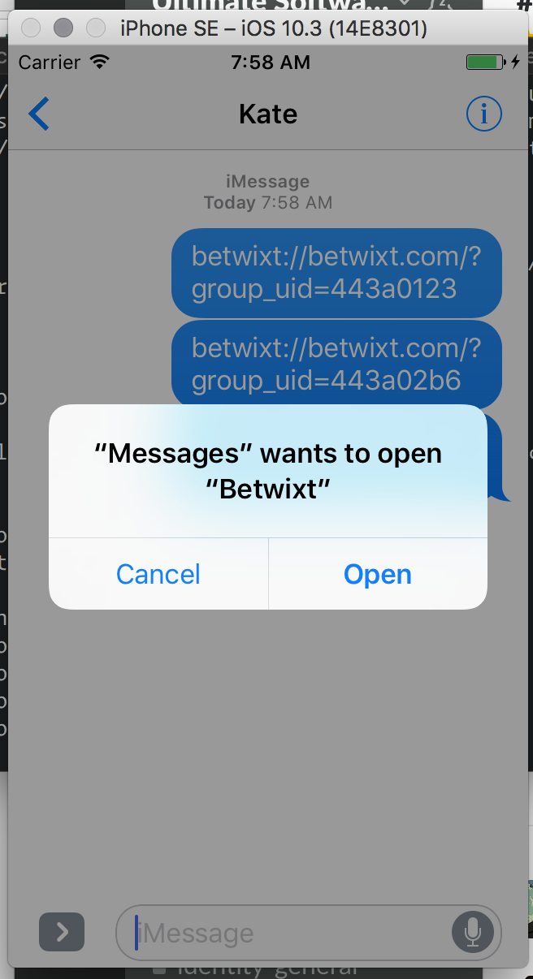

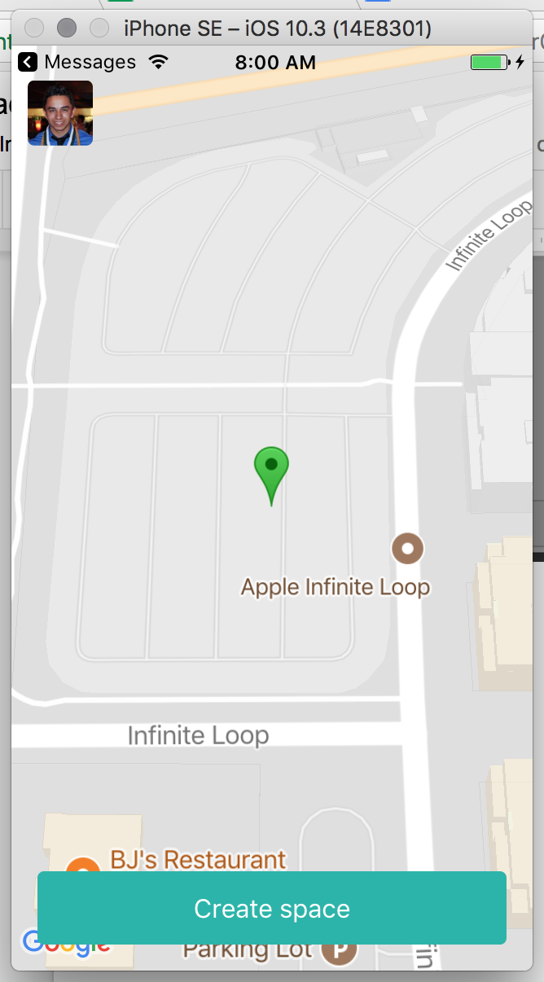

**User Story Name: [BUG] Not Connecting Users**

* Description: As a user, I want to get connected with whoever joins my space link when I share it with them.

**Use Case**

* Name: Get Connected
* Actor: A virtual employee
* Preconditions: Actor has opened the app on their phone
* Description:

1. Actor clicks on create space button on the bottom
2. App displays the space link to share with others
3. Actor copies the space link and shares it with others
4. Actor can see that others have joined the space

**Use Case Diagram**

[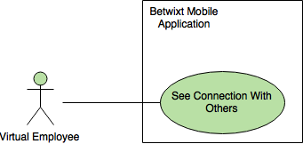](https://www.draw.io/#G0B5wDOQeZQxiaZXFuOXJmd3RDbkU)

**Sequence Diagram**

[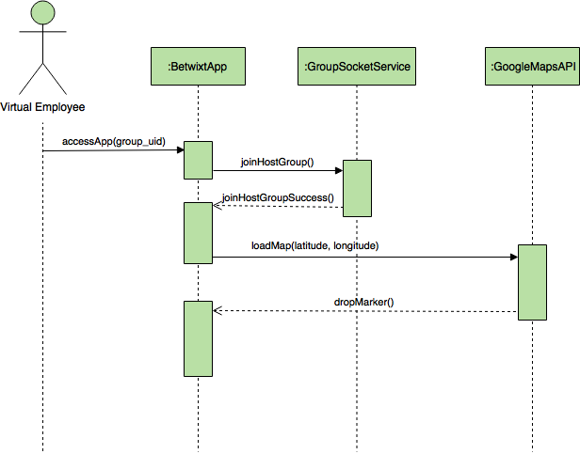](https://www.draw.io/#G0B5wDOQeZQxiaZ2d4b2thYUhlY3c)

**Class Diagram**

Not applicable.

**Unit Test**

* Test case ID: 001
* Description/Summary of Test: Display to the user that they are connected to the other users with the space link provided
* Pre-condition: The user has distributed the space link to others and they have joined
* Expected Results: See that other users are connecting
* Actual Result: Other users were connecting and got connected
* Status (Fail/Pass): Pass

**Visual User Guide**

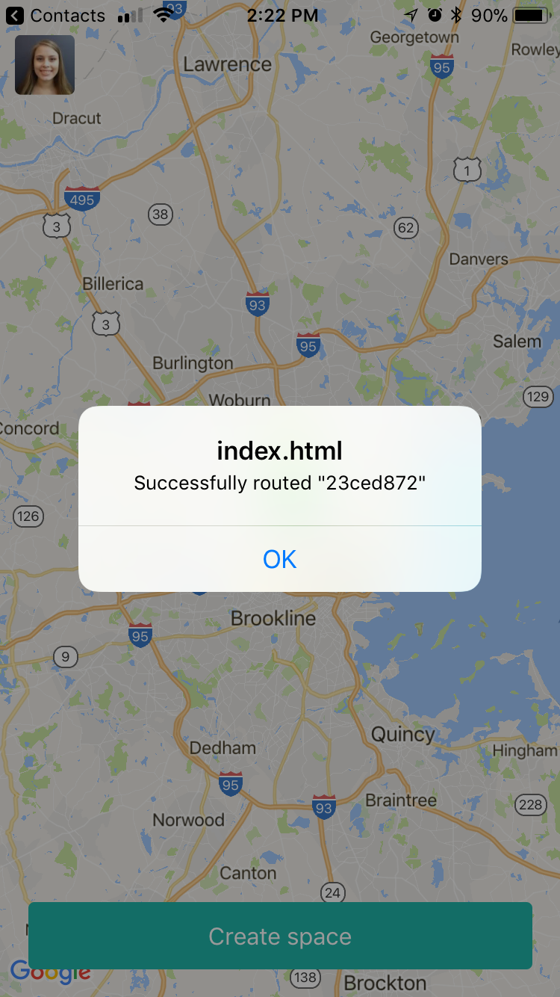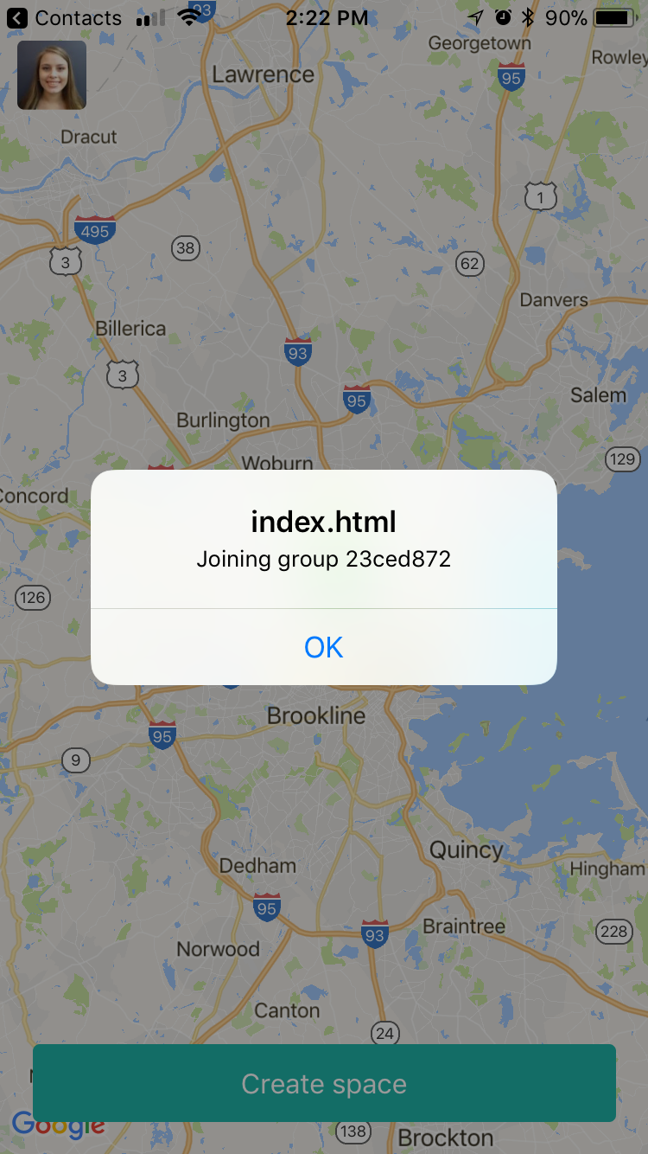

After clicking on the space link that was shared with me, as a user, I can see that I am successfully routed and can see that I have joined the group. This means that the user was successfully connected.

**User Story Name: Show Directions**

* Description: As a user, I would like to be shown the directions to the central location so that I can seamlessly get directions without having to refer to another application manually.

Acceptance Criteria

1. Directions are shown as a result of clicking on the central location

**Use Case**

* Name: Show Directions
* Actor: A virtual employee
* Preconditions: Actor has joined a group on the application.
* Description:

1. The user clicks on the central location.
2. The app redirects to the appropriate maps application (Google maps if installed. If not, it uses Apple Maps if iOS).

**Use Case Diagram**

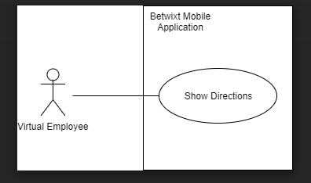

**Sequence Diagram**

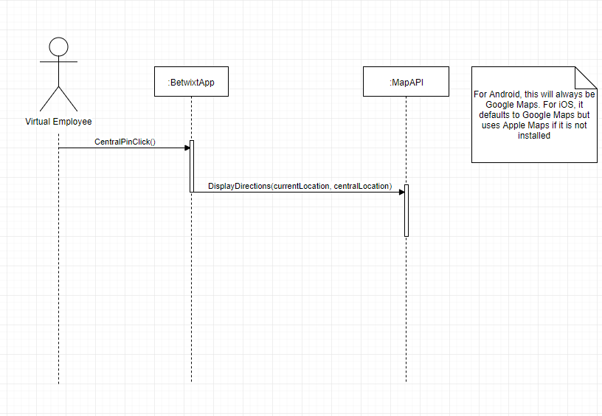

**Class Diagram**

N/A

**Unit Tests**

* Test case ID: 001
* Description/Summary of Test: Show directions on Google Maps when central location clicked.
* Pre-condition: Google maps is installed.
* Expected Results: See directions from central to current location on Google Maps.
* Actual Result: Saw directions from current to central location on Google Maps.
* Status (Fail/Pass): Pass
* Test case ID: 002
* Description/Summary of test: Show directions on native iOS Maps app when central location clicked.
* Pre-condition: Google Maps is not installed
* Expected Results: Saw directions from current to central location on iOS Maps app.
* Status (Fail/Pass): Pass

**Visual User Guide**

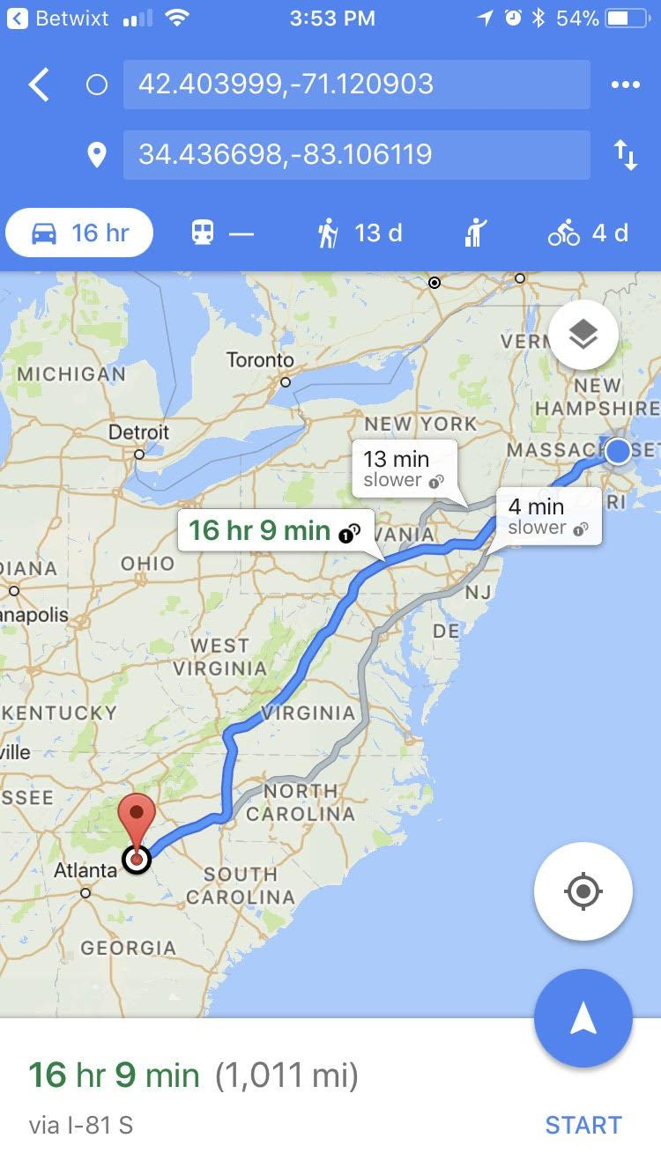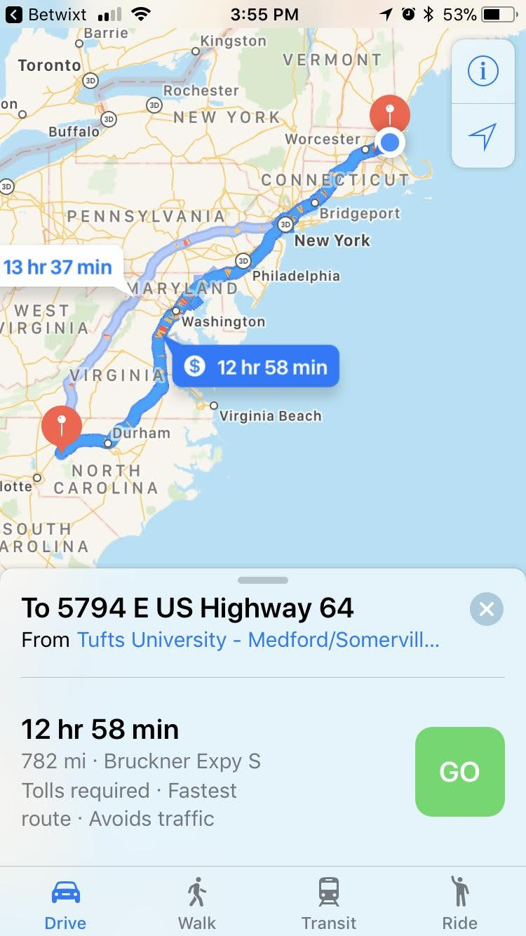

With Google Maps Without Google Maps (iOS)

**User Story Name: Give User Locations to Meet**

* Description: As a user (admin of space), I want to see a list of suggestions for places to meet up and select that place.

Acceptance Criteria

1. Show a list of suggestions as well as how far it is from the central location
2. Drop a pin on the selected suggestion (the admin can only pick the suggestion)

**Use Case**

* Name: See List Of Locations And Select One
* Actor: A virtual employee who is also the admin of the space
* Preconditions: Actor has opened the app on their phone and has created a space
* Description:

1. Actor clicks on “Select A Location” button after creating the space
2. App displays a list of locations
3. Actor selects a location
4. App drops a red pin on the selected location to everyone that’s part of the space

**Use Case Diagram**

[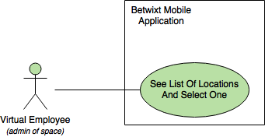](https://www.draw.io/#G0B5wDOQeZQxiaaHY4bDZOMXpUemc)

**Sequence Diagram**

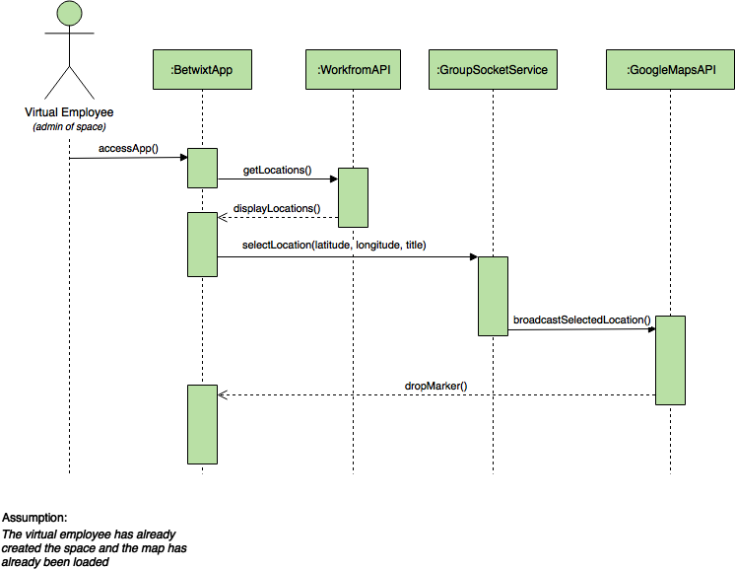

**Class Diagram**

Not applicable.

**Unit Test**

* Test case ID: 001
* Description/Summary of Test: Select a location and drop a red pin on all devices that are connected to that space with the selected location
* Pre-condition: The user has distributed the space link to others and they have joined
* Expected Results: See the selected location pin on the map
* Actual Result: The pin with the selected location was dropped on the map and everyone can see it
* Status (Fail/Pass): Pass

**Visual User Guide**

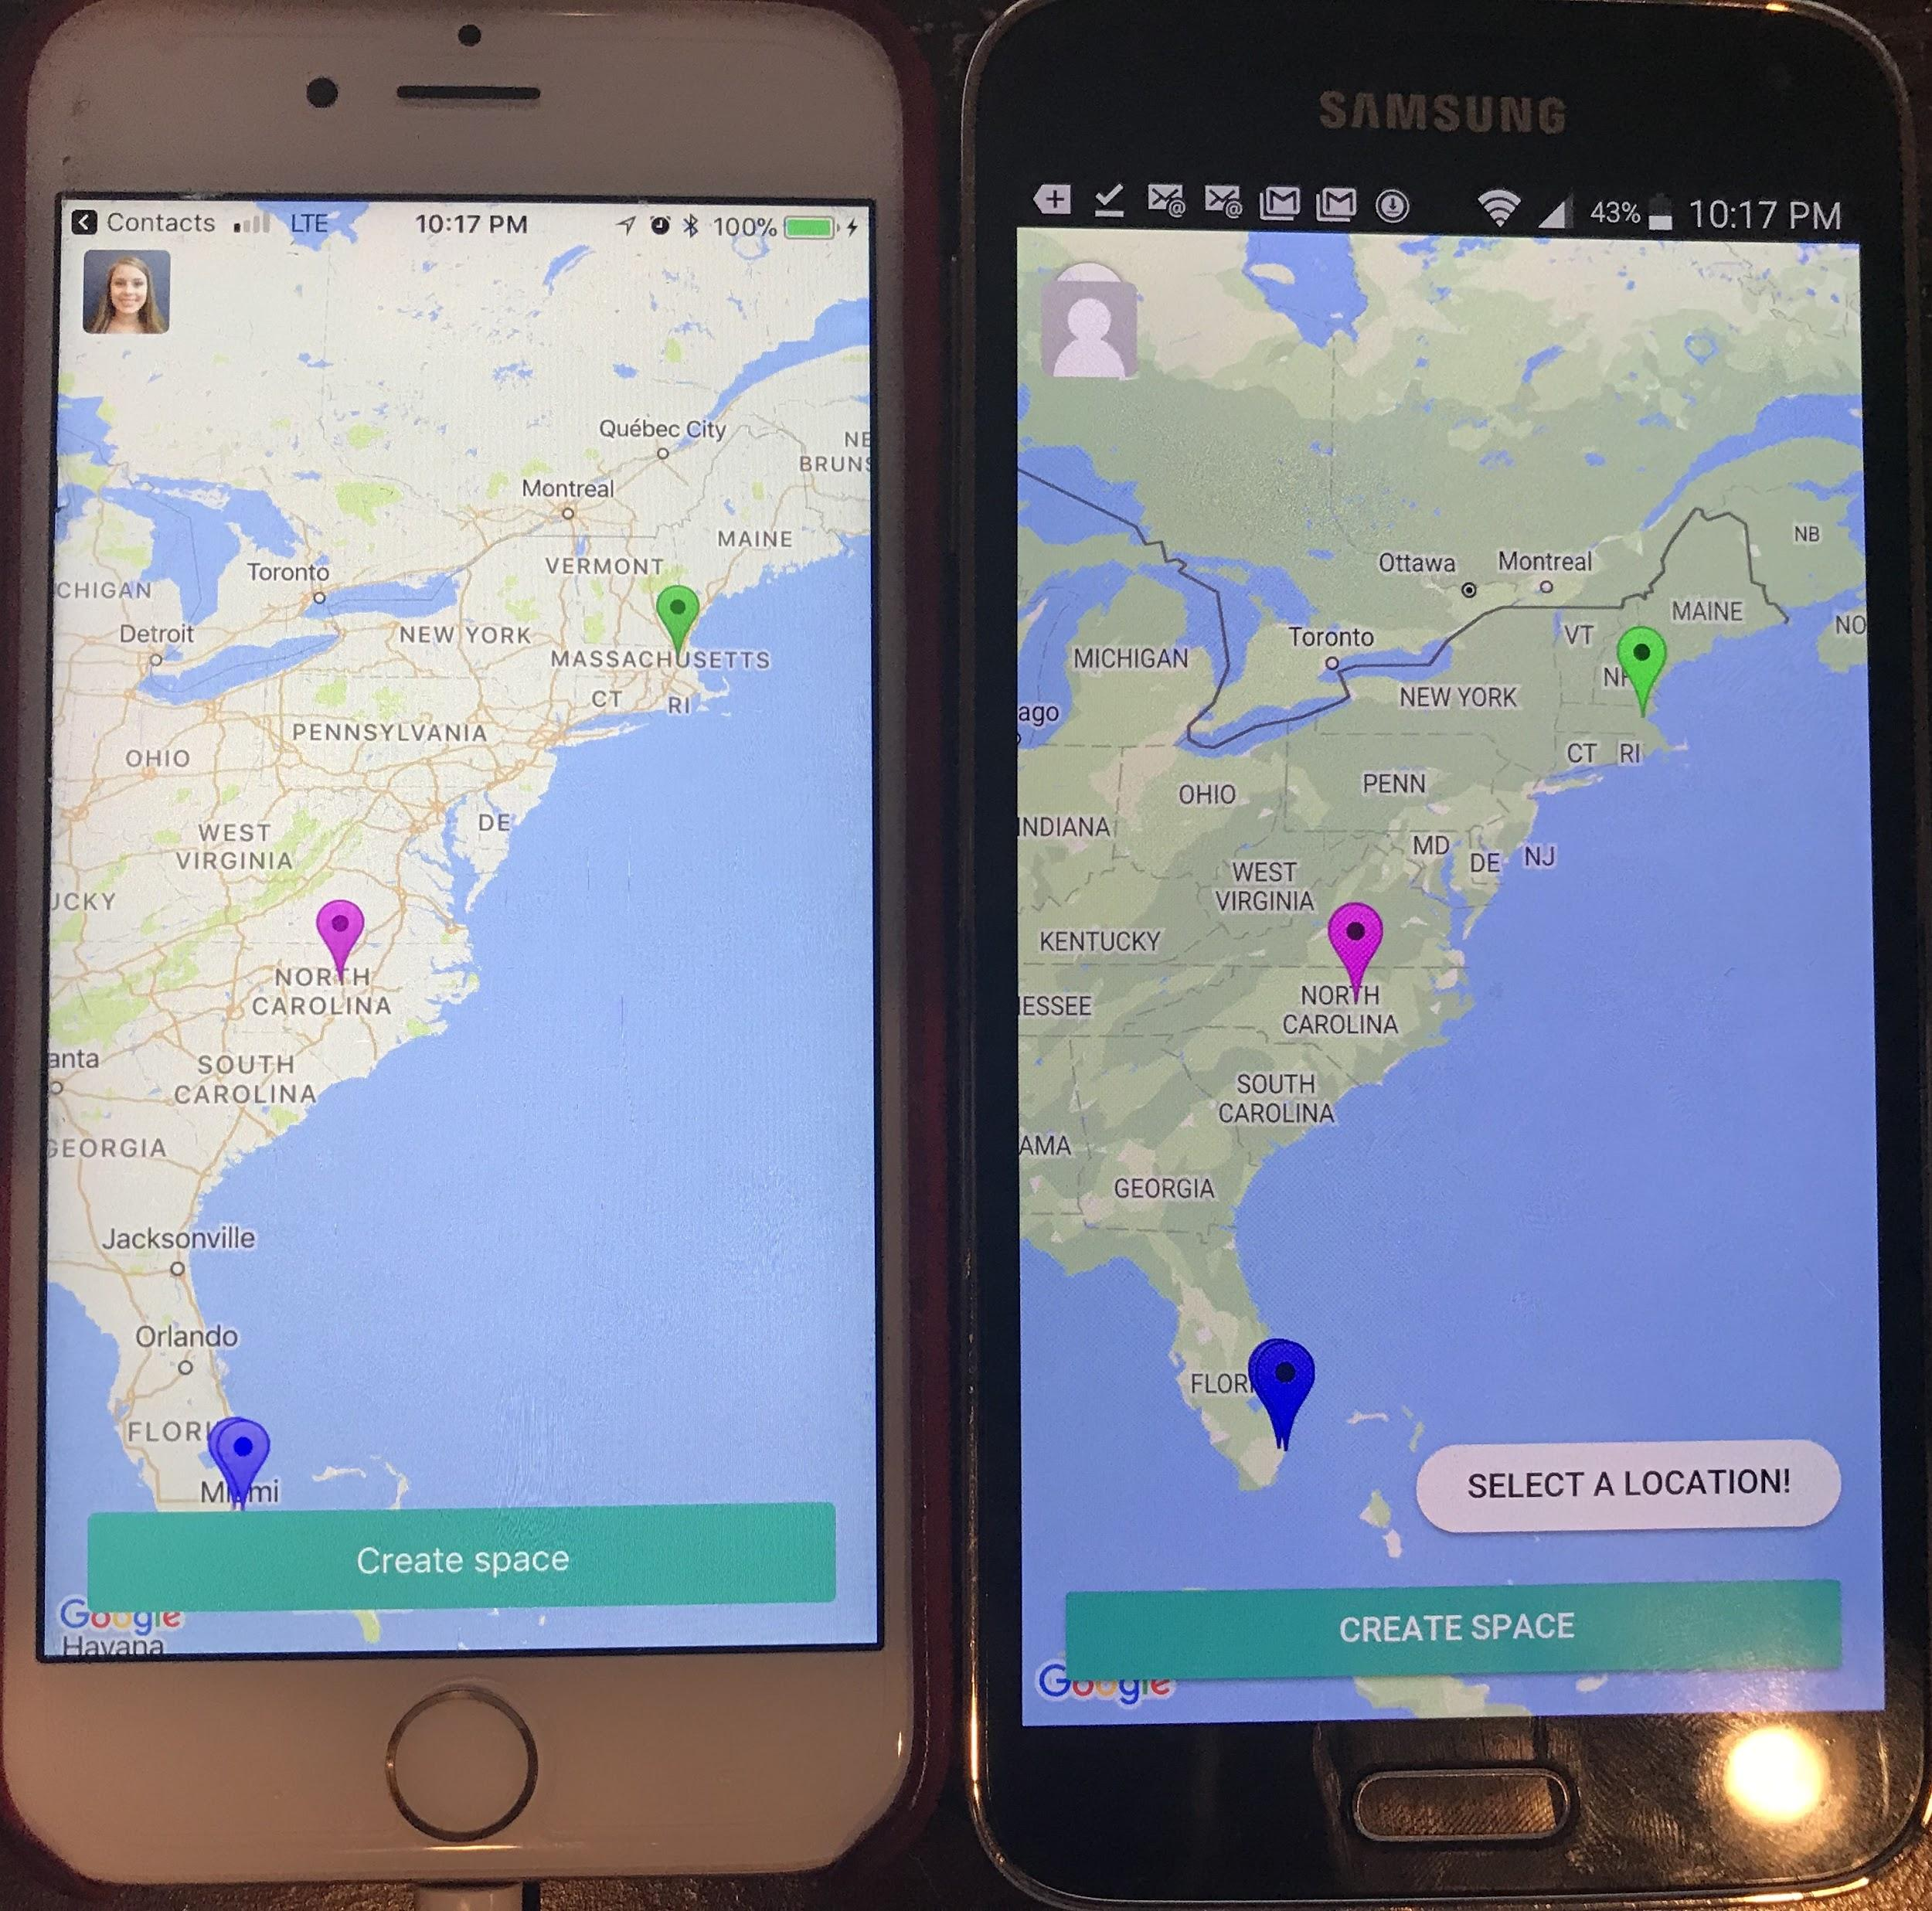

The samsung phone on the right has already created a space and shared the link with the user on the left. As you can see, the user on the right now has the ability to select a location.

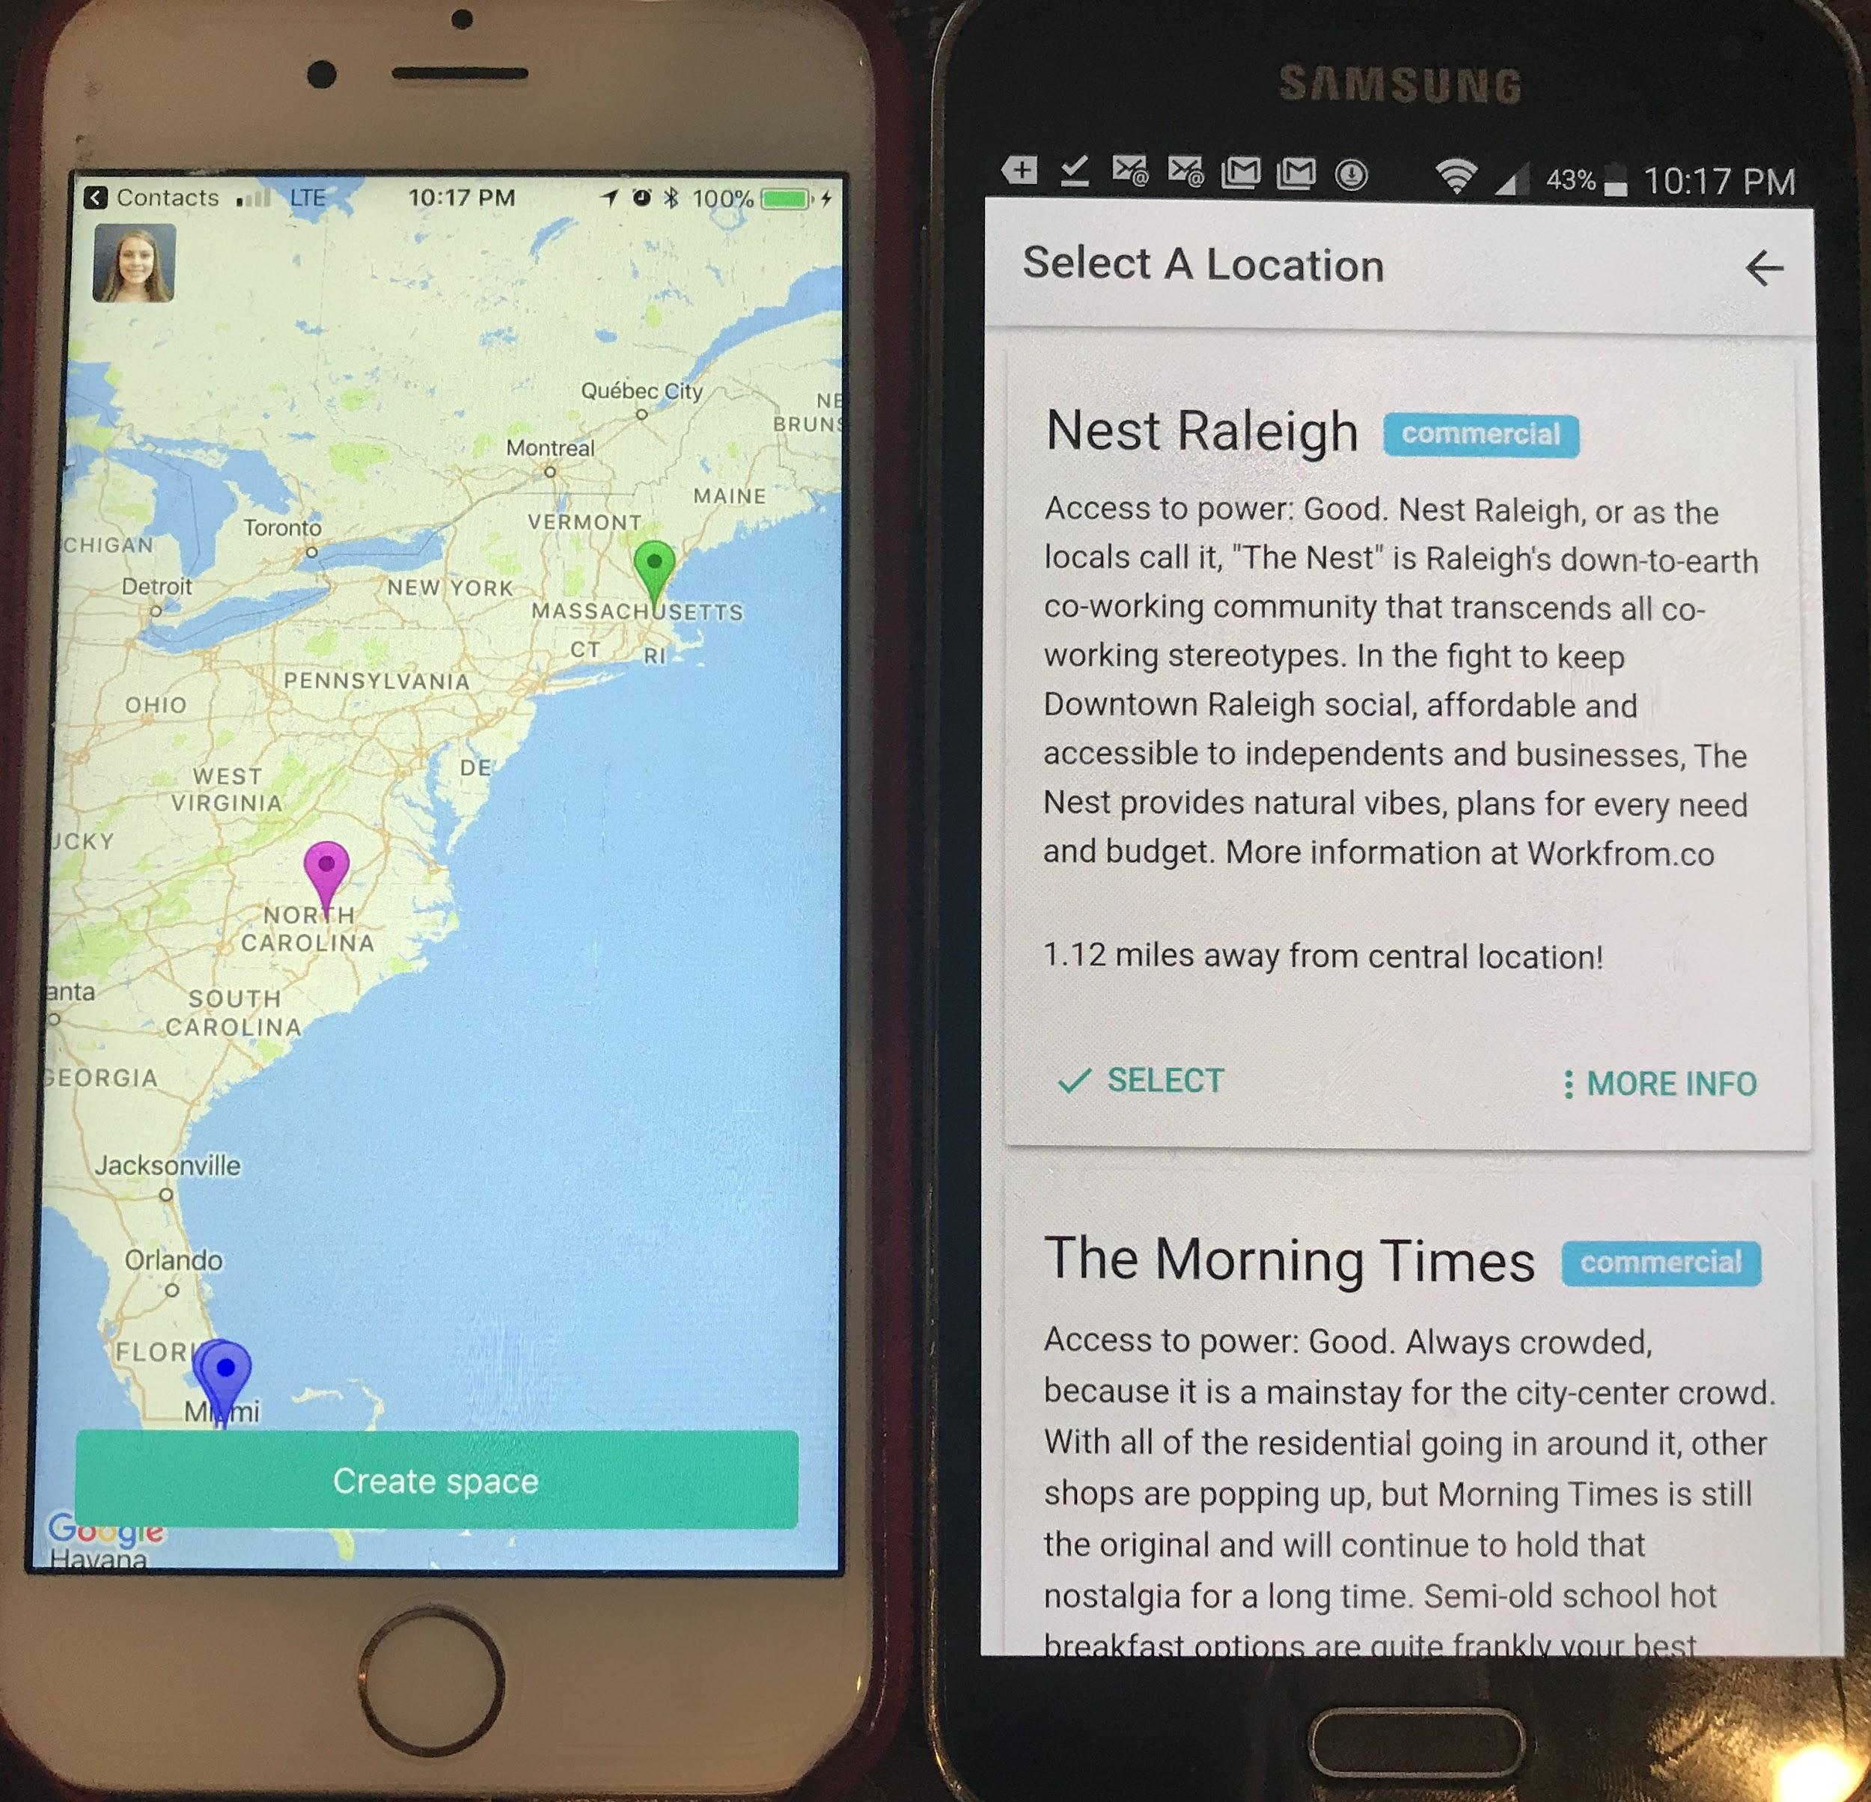

After selecting the “Select A Location” button, the user is presented with a list of places to select from with a useful description.

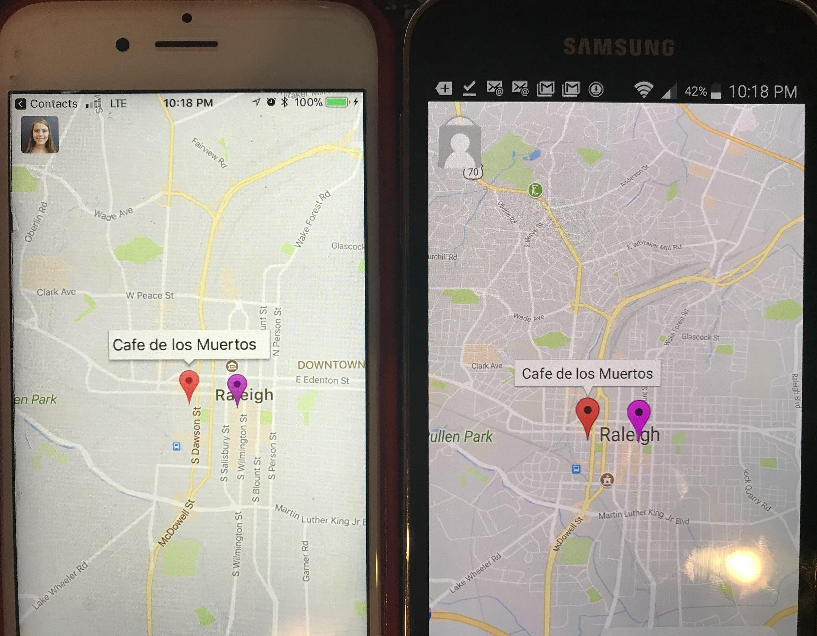

Here, the user on the right has selected the desired location and the red pin has been dropped on everyone that is part of the selected location.

**User Story Name: What to do when the central location is on the ocean**

* Description: **As a** User **I would like** to be able to move the central location when it is calculated to be in the ocean **so that** I may pick a reasonable location to meet up in.

Acceptance Criteria

1. Detect that the central location is in water
2. Inform the user
3. Allow the user to move the central location in this case

**Use Case**

* Name: Move central location when it is in the ocean or in water
* Actor: A virtual employee
* Preconditions: That a virtual employee is in a space in the app and the central location is calculated to be in the ocean or in water.
* Description <Flow of events>:

1. A space is created and multiple virtual employees join

2. The central location is calculated to be in the ocean

3. The virtual employees are notified

4. The central location becomes movable and it may be placed on land.

**Use Case Diagram <**you can use draw.io**>**

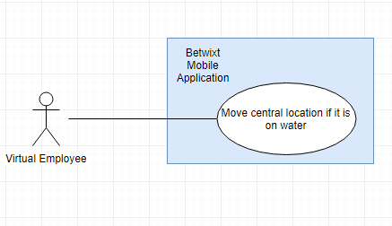

**Sequence Diagram**

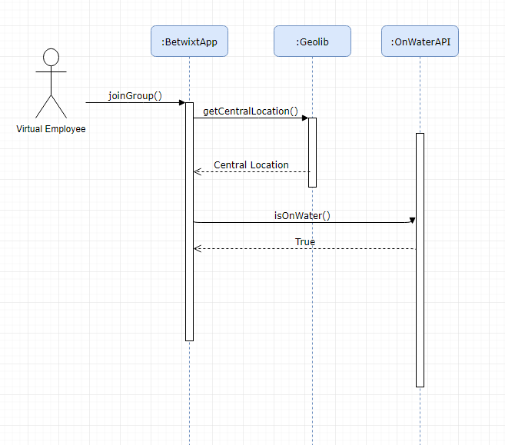

**Class Diagram**

N/A

**Unit Test**

* Test case ID: 001
* Description/Summary of Test: Central location is movable if it is calculated to be on water
* Pre-condition: The central location is calculated and it is on water
* Expected Results: The central location pin becomes movable and can be dragged onto land.
* Actual Result: The central location became movable and was able to be moved onto land.
* Status (Fail/Pass): Pass

**Integration Test**

N/A

**Visual User Guide** <like one or two screenshots of the feature. For the hardware project, a photo of device is required>

**User Story Name: Save Default Preferences On Profile**

* Description: As a user, I would like to save my default space preferences on my profile so that every time I create a space, the same preferences are applied.

Acceptance Criteria

1. Save on Profile the space preferences
2. Apply the preferences as part of the search of locations

**Use Case**

* Name: Save Space Preferences On Profile
* Actor: A virtual employee
* Preconditions: Actor has opened the app on their phone
* Description:

1. Actor clicks on their profile picture on the upper left hand corner of the screen
2. App displays their profile information to edit
3. Actor can change their space preferences to their choosing and clicks save
4. App saves the profile information on local storage and every time the actor creates a space, they can see the space preferences are the same as the ones on their profile

**Use Case Diagram**

[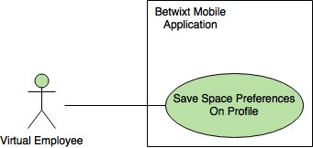](https://www.draw.io/#G0B5wDOQeZQxiaTjdHaTRtdGpkZmc)

**Sequence Diagram**

[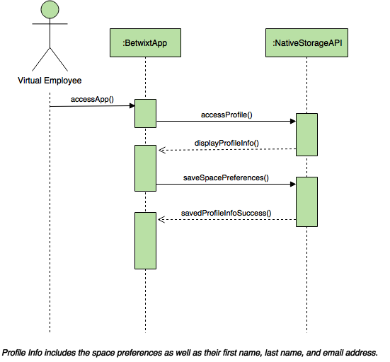](https://www.draw.io/#G0B5wDOQeZQxiaTDllY3BNc0tJUkU)

**Class Diagram**

Not applicable.

**Unit Test**

* Test case ID: 001
* Description/Summary of Test: Save Preferences On Profile and See them after clicking on create space
* Pre-condition: None.
* Expected Results: See default preferences after clicking on create space
* Actual Result: Saw default preferences after clicking on create space
* Status (Fail/Pass): Pass

**Visual User Guide**

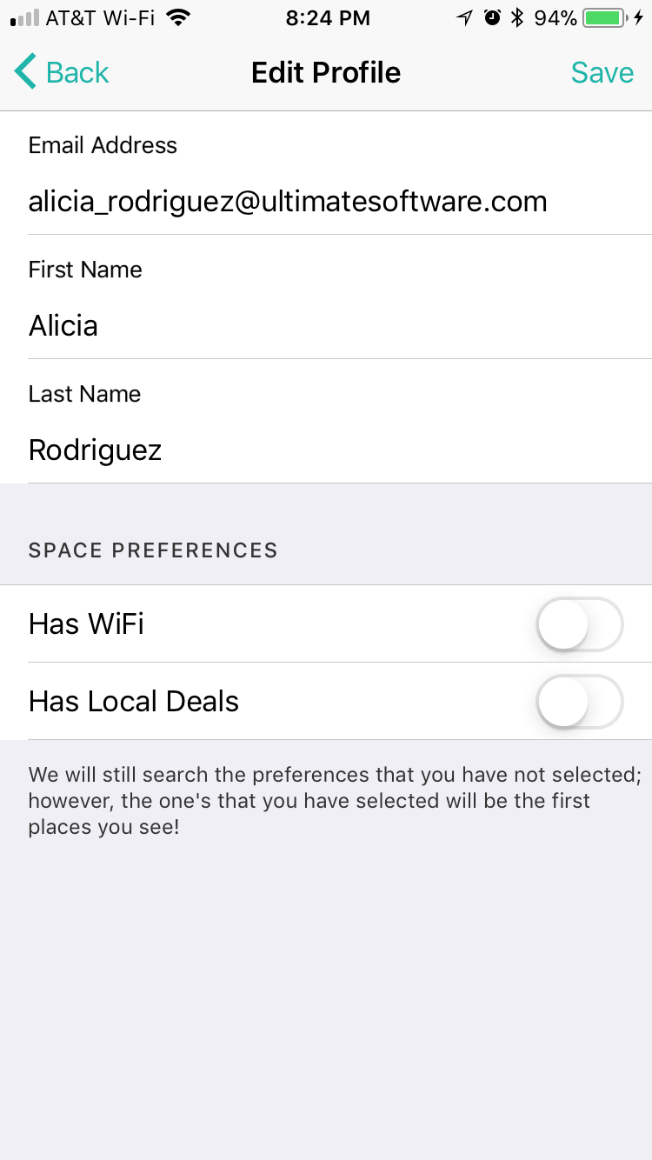

The user has clicked on their profile picture on the upper left hand corner and it displays this as their profile. They have the option to set space preferences.

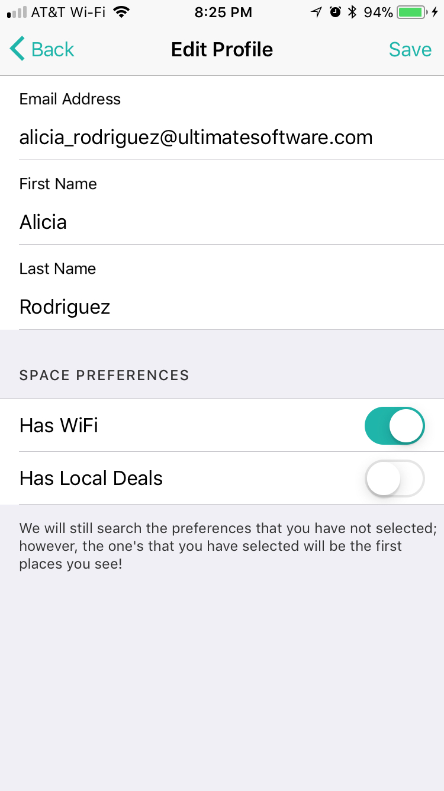

The user has decided to set their space preferences to make sure that the location has wifi. Then the user clicks save.

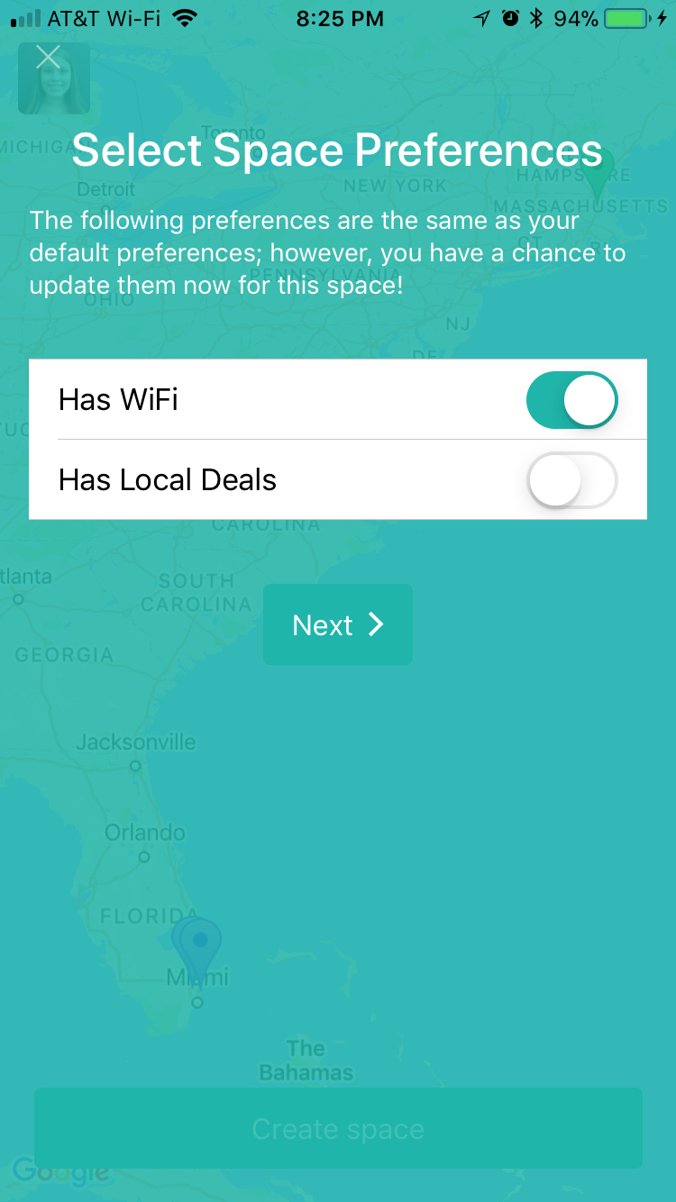

After the user has clicked on the create space button, they see this screen and they can tell that it is getting the information from their profile since it is the same.

**User Story Name: Automated Testing - Adding random users**

* Description: As a developer, there should be a tool to add random user pins so that testing of the feature and other features related to users joining groups can be done expediently.

Acceptance Criteria

1. Button that can easily be removed from the app for production which adds a user.
2. User location must be random

**Use Case #1**

* Name: Add random user
* Actor: A developer
* Preconditions: Actor has created or joined a group
* Description:

1. Actor clicks on a button to generate a user.

**Use Case Diagram #1**

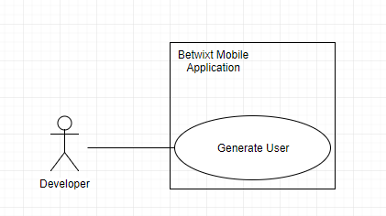

**Sequence Diagram**

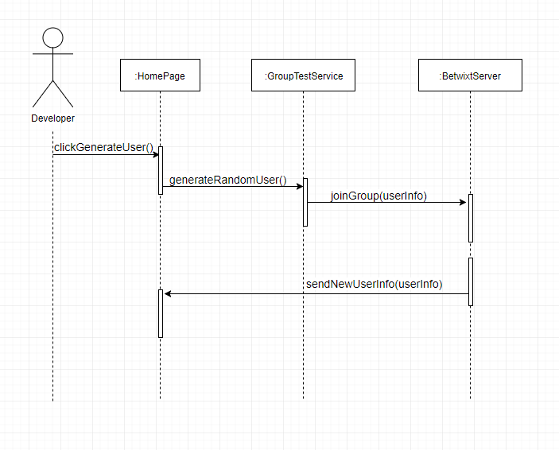

**Class Diagram**

Not applicable.

**Unit Test**

* Test case ID: 001
* Description/Summary of Test: Pin drops on random location within 10 mile radius when generate user button is clicked
* Pre-condition: User is in group.
* Expected Results: Pin drops at random user location
* Actual Result: Pin dropped at a random location within a 10 mile radius of user’s location.
* Status (Fail/Pass): Pass

**Visual User Guide**

Generate user button shown when you create or join a group

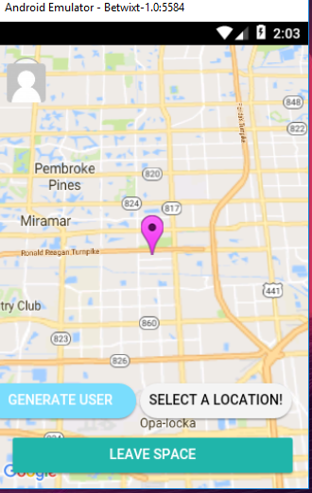

Generated 2 users. Their pins dropped randomly within a 10 mile radius.

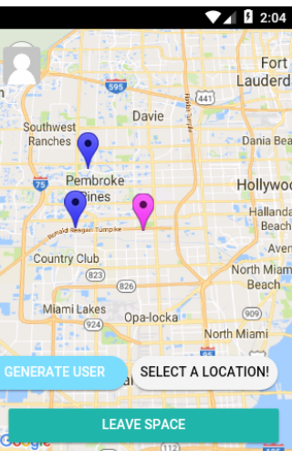

**User Story Name: [BUG] Admin Pin Not Dropping For Other Users**

* Description: As a user who joined a space, I would like to see the pin of the admin as well, so that I can see there’s other already in the space.

Acceptance Criteria

1. The admin pin needs to drop as well when others have joined the space.

**Use Case**

* Name: See Admin’s Pin Dropped When Joining Space
* Actor: A virtual employee
* Preconditions: Actor has opened the app on their phone
* Description:

1. Actor joins a space via a link.
2. Actor can see the admin’s pin drop.

**Use Case Diagram**

[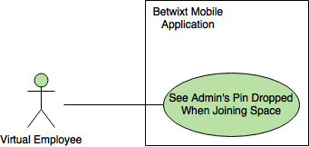](https://www.draw.io/#G1RASbOphXFGxqeA0nErNAiMjm6kPZhTvO)

**Sequence Diagram**

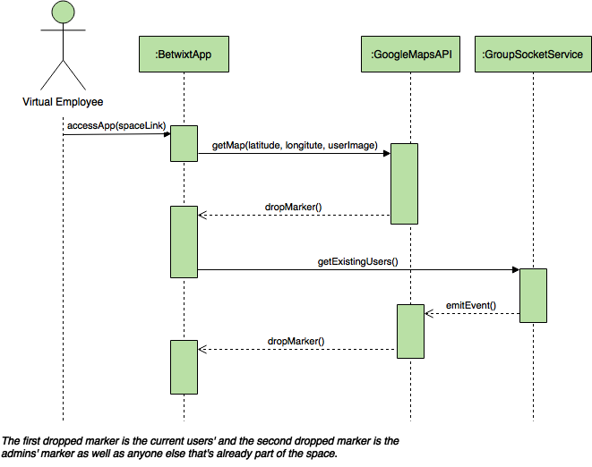

**Class Diagram**

Not applicable.

**Unit Test**

* Test case ID: 001
* Description/Summary of Test: Show admin pin when joining space
* Pre-condition: None.
* Expected Results: See the admin pin dropping when joining the space
* Actual Result: The admin pin dropped when joining the space
* Status (Fail/Pass): Pass

**Visual User Guide**

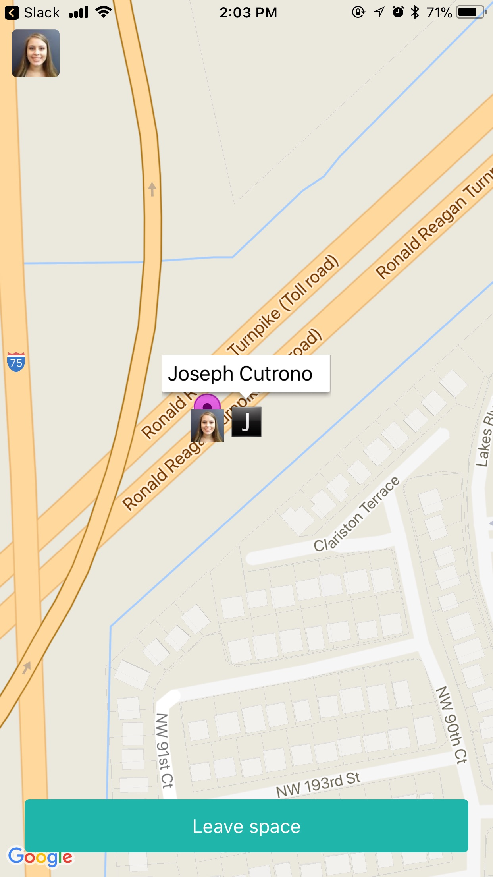

iOS Device

After Joseph has created a space on his phone and I have joined the space, I can now see his pin.

**User Story Name: User Pins Should Be Their Image**

* Description: As a user, when my pin is dropped, it should be my profile picture, so that everyone can see me on the map clearly, also when they click on the pin, it should display my name.

Acceptance Criteria

1. Profile picture needs to be the pin
2. Clicking on the pin displays the user’s name

**Use Case #1**

* Name: Display Profile Image As Current Location Pin
* Actor: A virtual employee
* Preconditions: Actor has opened the app on their phone
* Description:

1. Actor sees that their current location pin has been dropped as their profile picture

**Use Case Diagram #1**

[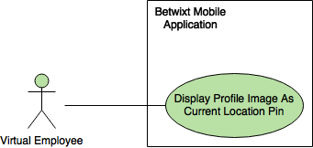](https://www.draw.io/#G1Tq-9ADIYBW6eHierM3uP70vIPhVwranx)

**Use Case #2**

* Name: See Other’s Profile Images And Name As Their Current Location
* Actor: A virtual employee (admin of space)
* Preconditions: Actor has opened the app on their phone
* Description:

1. Actor creates a space and shares the link with their co-workers
2. As the actor’s co-workers start to join, the actor can see their profile images dropping on the map as their pin.
3. The actor can click on their images and see their name as well.

**Use Case Diagram #2**

[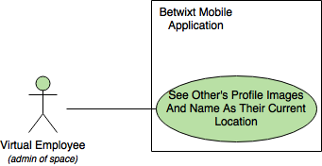](https://www.draw.io/#G1m1W6voXjj6cBiaw5KFIcDT3JWFBcUHgS)

**Sequence Diagram**

[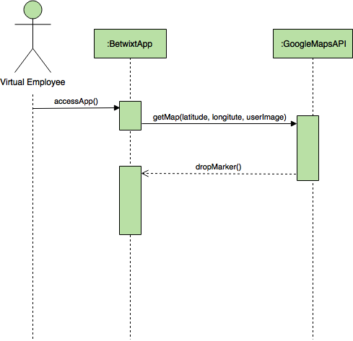](https://www.draw.io/#G16mrThUUibjWQulmJRpGpTUh8_vJi2OPh)

**Class Diagram**

Not applicable.

**Unit Test**

* Test case ID: 001
* Description/Summary of Test: Display user’s profile image as their current location instead of a pin
* Pre-condition: None.
* Expected Results: See the user’s profile image as their current location pin
* Actual Result: Saw the user’s profile image as their current location pin
* Status (Fail/Pass): Pass

**Visual User Guide**

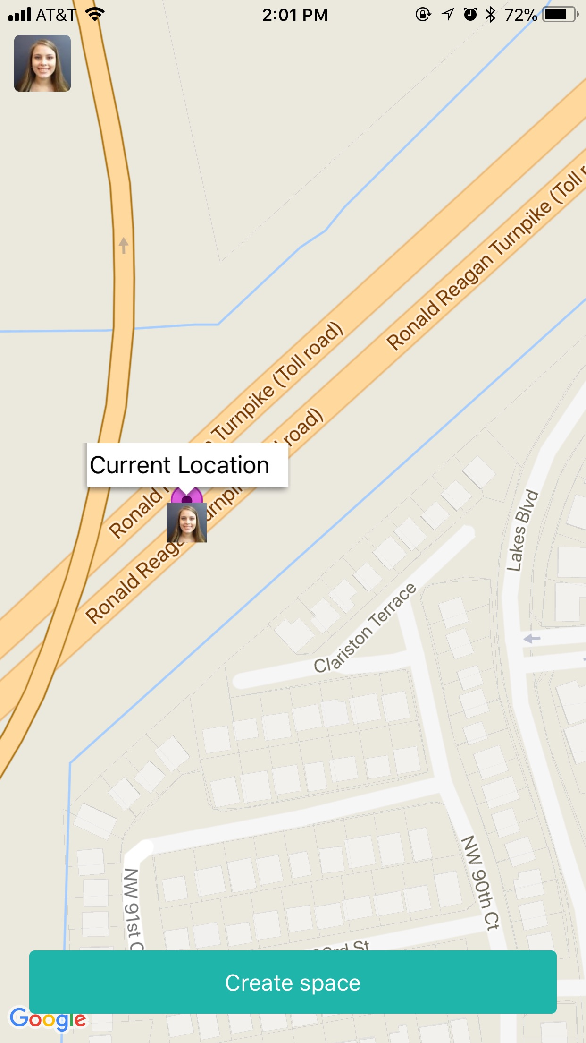

iOS Device

After the user has opened the app, they can see that their current location pin has dropped as their profile image.



iOS Device

After Joseph has created a space on his phone and I have joined the space, I can see his pin and click on it to see his name.

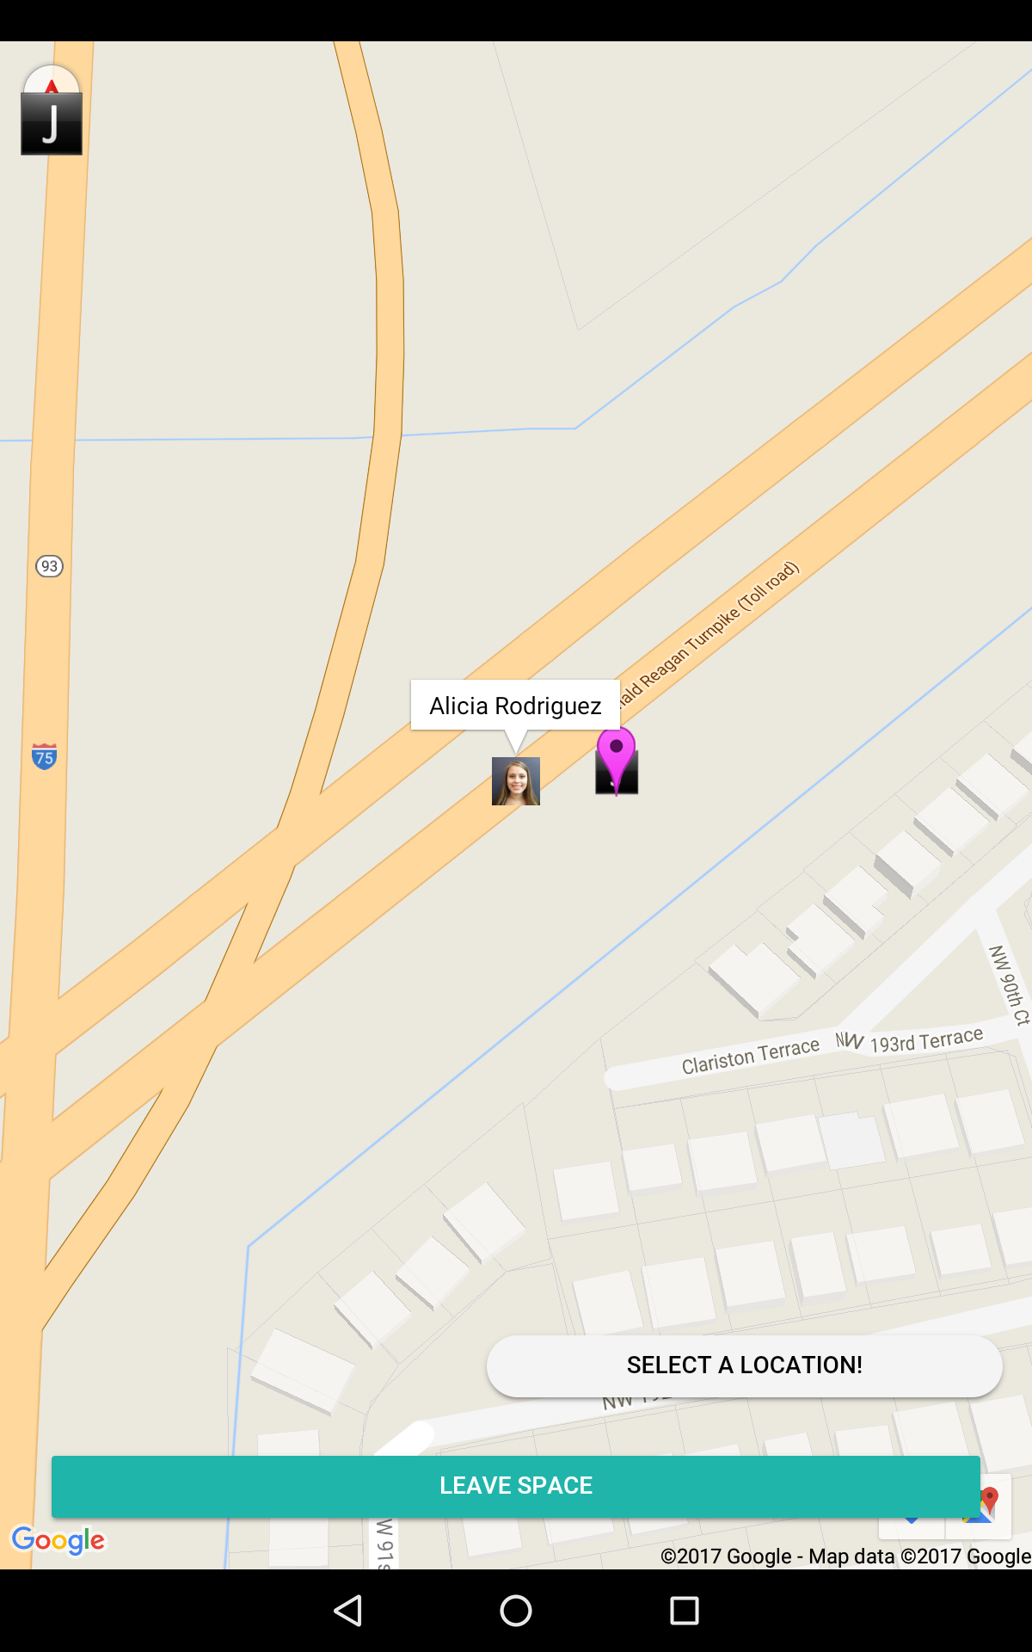

Android Device

Joseph can now see that I have joined the space and click on my image to see my name.

**User Story Name: Leave group for people who join the group**

* Description: As a user, I would like all pins removed when I leave a group except for my current locations so that I can join another group and not have old pins.

Acceptance Criteria

1. When a user is in a group and they leave, all pins should be removed except for the current location.

**Use Case**

* Name: Remove pins when a user leaves a group
* Actor: A virtual employee
* Preconditions: That a virtual employee is in a group and has more pins on the map that need to be removed when they leave.
* Description <Flow of events>:

1. A space is created and multiple virtual employees join

2. There are multiple pins dropped on the user’s map.

3. The user leaves the group.

4. All pins except for the location of the user are removed.

**Use Case Diagram <**you can use draw.io**>**

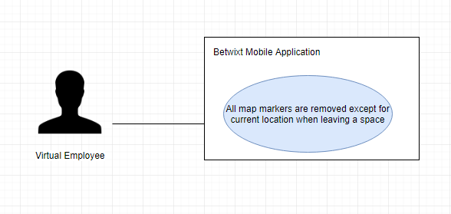

**Sequence Diagram**

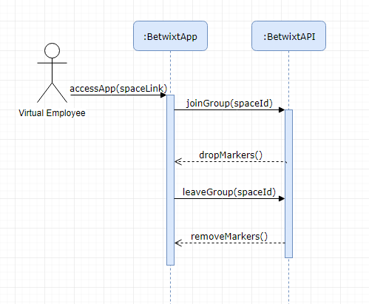

**Class Diagram**

N/A

**Unit Test**

* Test case ID: 001
* Description/Summary of Test: All pins are removed except for current location when leaving a group
* Pre-condition: You are in a space and there are other pins on the map
* Expected Results: All pins are removed except for the current location
* Actual Result: All pins were removed except for the current location
* Status (Fail/Pass): Pass

**Integration Test**

N/A

**Visual User Guide** <like one or two screenshots of the feature. For the hardware project, a photo of device is required>

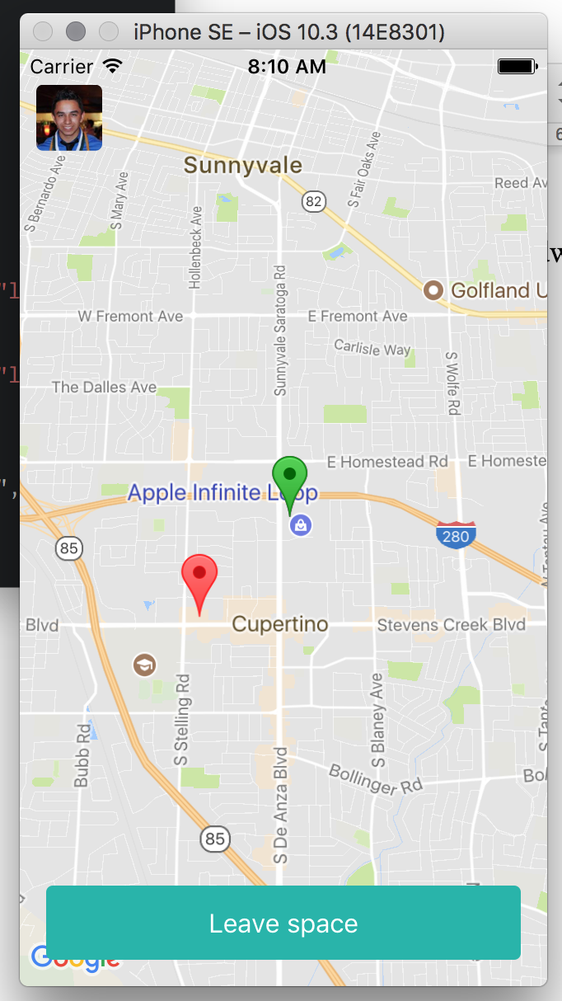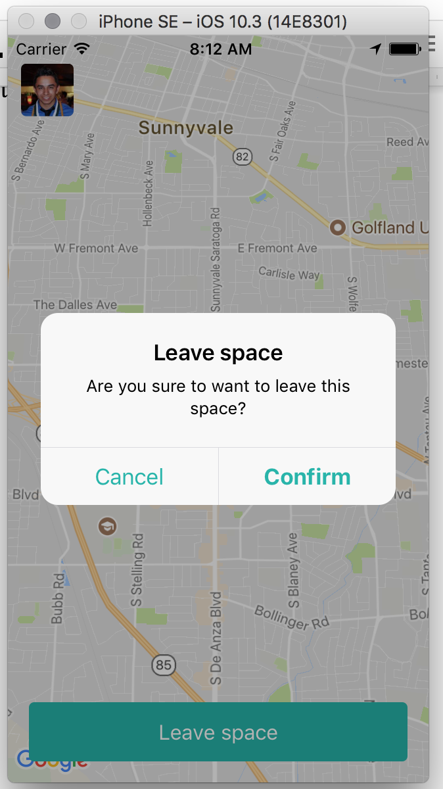

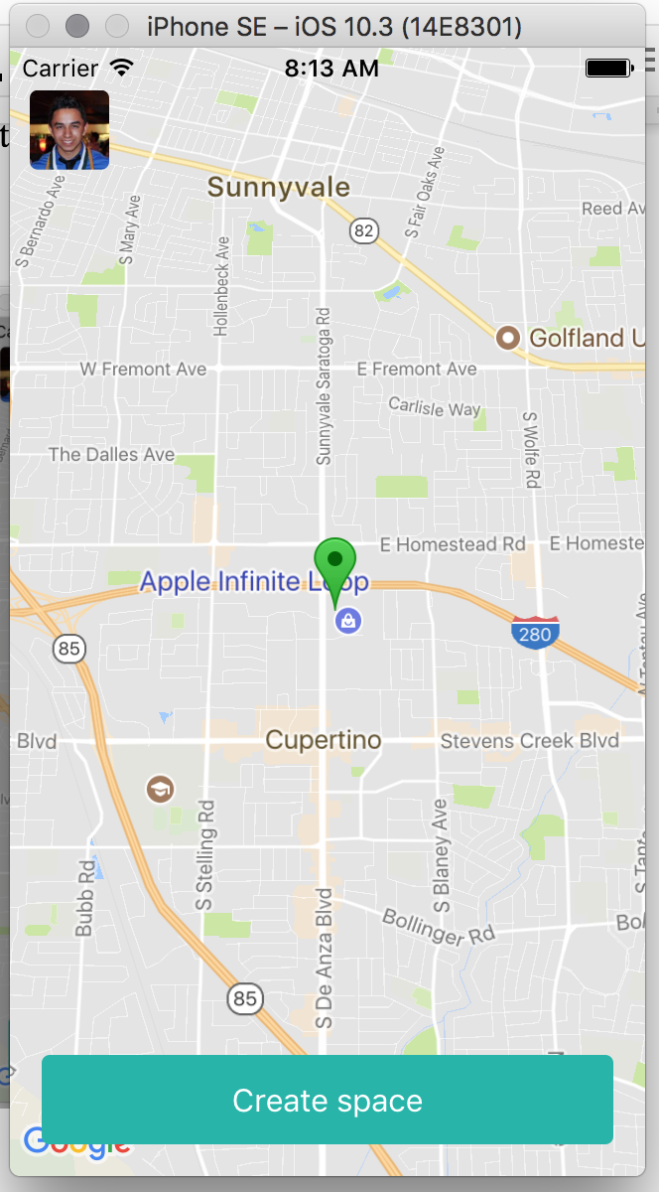

**User Story Name: Calculate the central location after users have joined the group**

* Description: As a user, I would like the central location to be recalculated after a user has joined the group so that it can be an accurate representation of the central location.

Acceptance Criteria

1. Central location is recalculated when a user joins the group.

**Use Case**

* Name: Recalculate central location
* Actor: A virtual employee
* Preconditions: Space owner has created a space
* Description:

1. First Actor joins the group
2. System calculates central location
3. Second Actor joins the group
4. Central location is recalculated

**Use Case Diagram**

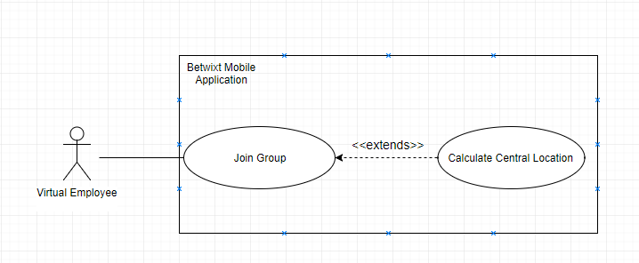

**Sequence Diagram**

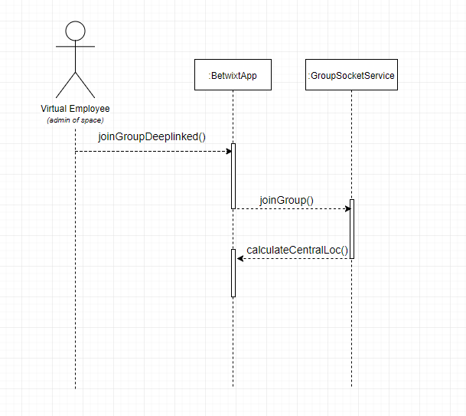

**Class Diagram**

Not applicable.

**Unit Test**

* Test case ID: 001
* Description/Summary of Test: Recalculate central location
* Pre-condition: A Space has been created by another user and there are two people in the space.
* Expected Results: The central location pin moves to the recalculated central location when a new user joins.
* Actual Result: The central location pin moved.
* Status (Fail/Pass): Pass

**Visual User Guide**

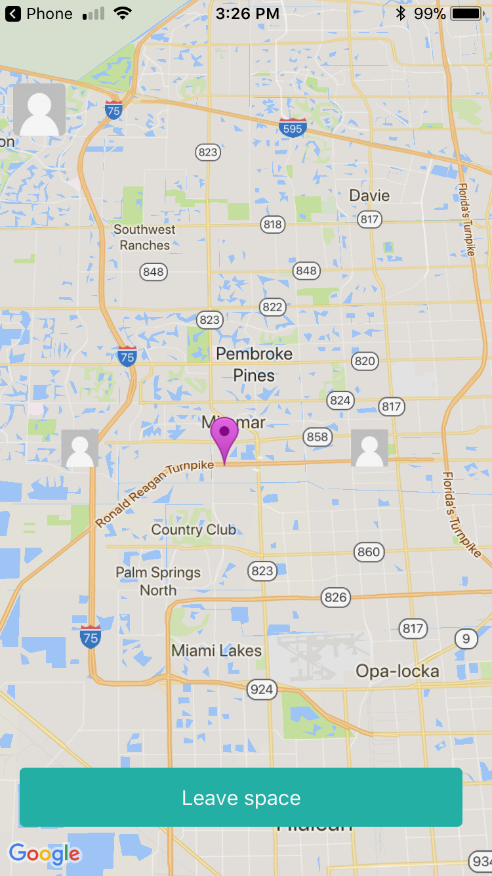

There is a space with two users. The central location pin is denoted by the purple pin in the middle.

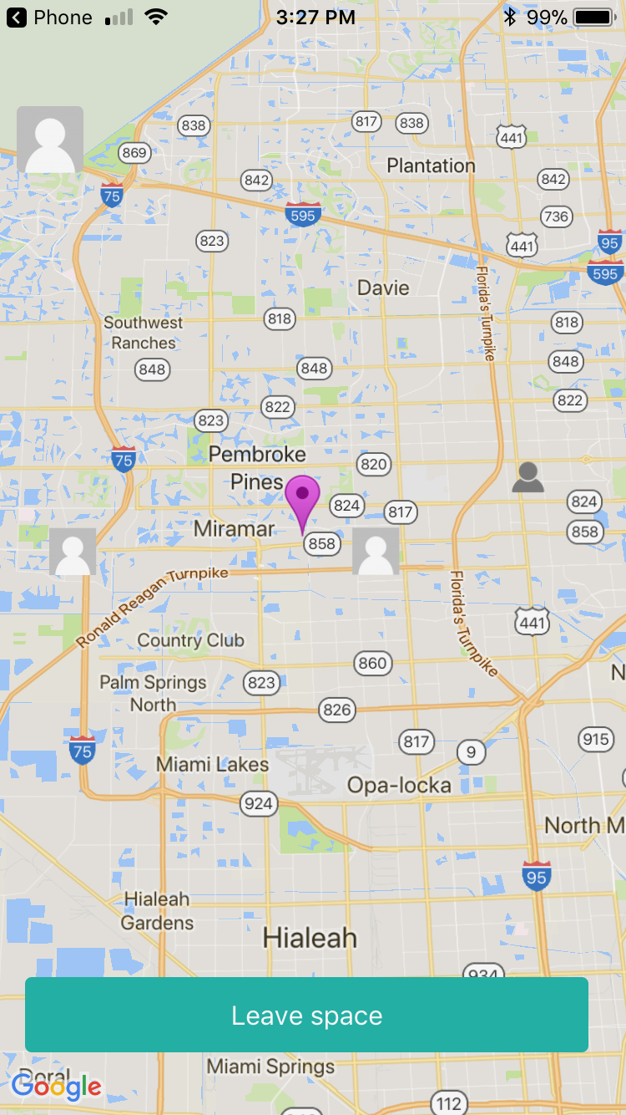

A new user joins (dark grey icon). The central location is recalculated and the pin moves accordingly.

**User Story Name: Choose New Meeting Location**

* Description: As an admin of a space, after selecting a location to meet up, I would like to select a new meeting location, so that I can have the choice of changing it.

Acceptance Criteria

1. Select new location and remove old pin and drop new.

**Use Case**

* Name: Select New Meeting Location
* Actor: A virtual employee (admin of space)
* Preconditions: Actor has opened the app on their phone & has created a space & users have already joined
* Description:

1. Actor selects a location to meet up
2. Actor can see the pin dropping
3. Actor selects a new location to meet up
4. Actor sees alert messages saying that the old location has been removed and that a new location has been chosen
5. Actor can see that the old pin has been removed and the new pin has been dropped

**Use Case Diagram**

[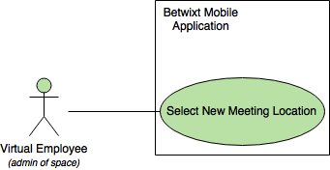](https://www.draw.io/#G1y13_NV33j-X48k7E4ugM0rzhgnuQR7pT)

**Sequence Diagram**

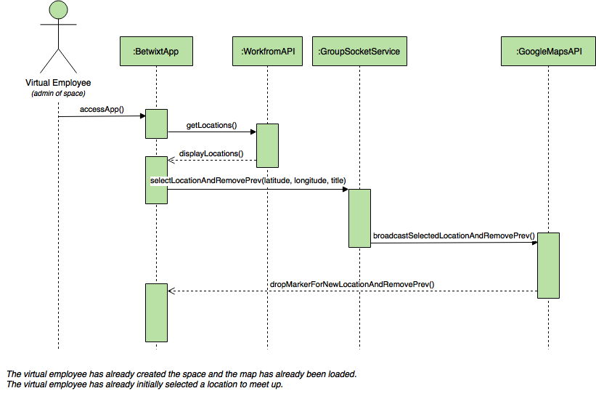

**Class Diagram**

Not applicable.

**Unit Test**

* Test case ID: 001
* Description/Summary of Test: Select new location
* Pre-condition: None.
* Expected Results: See the new location pin dropping and the previous one removed
* Actual Result: See new selected location pin dropped and the previous one removed
* Status (Fail/Pass): Pass

**Visual User Guide**

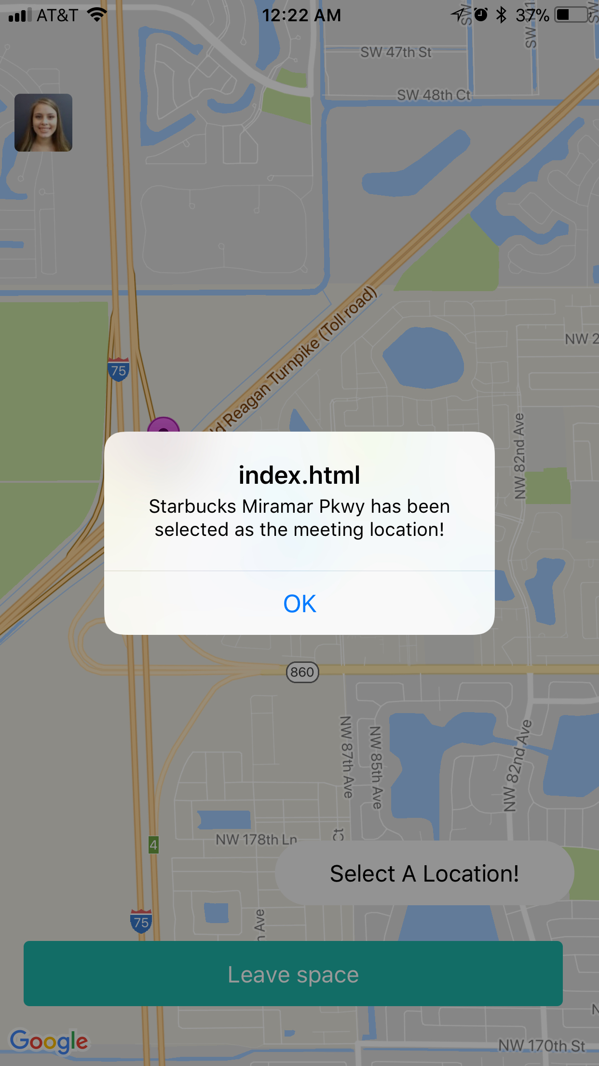

iOS Device

After the space admin has already selected a meeting location and decided to choose Starbucks as the new one...

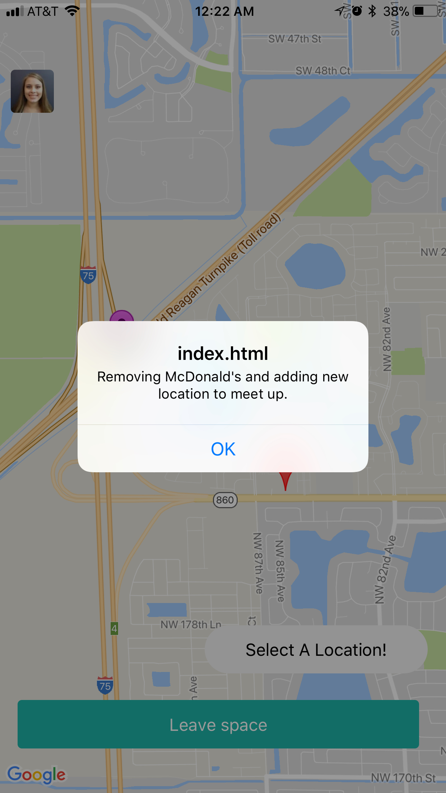

iOS Device

We can see here that the previous location, McDonald’s has been removed and a new meeting location is taking place.

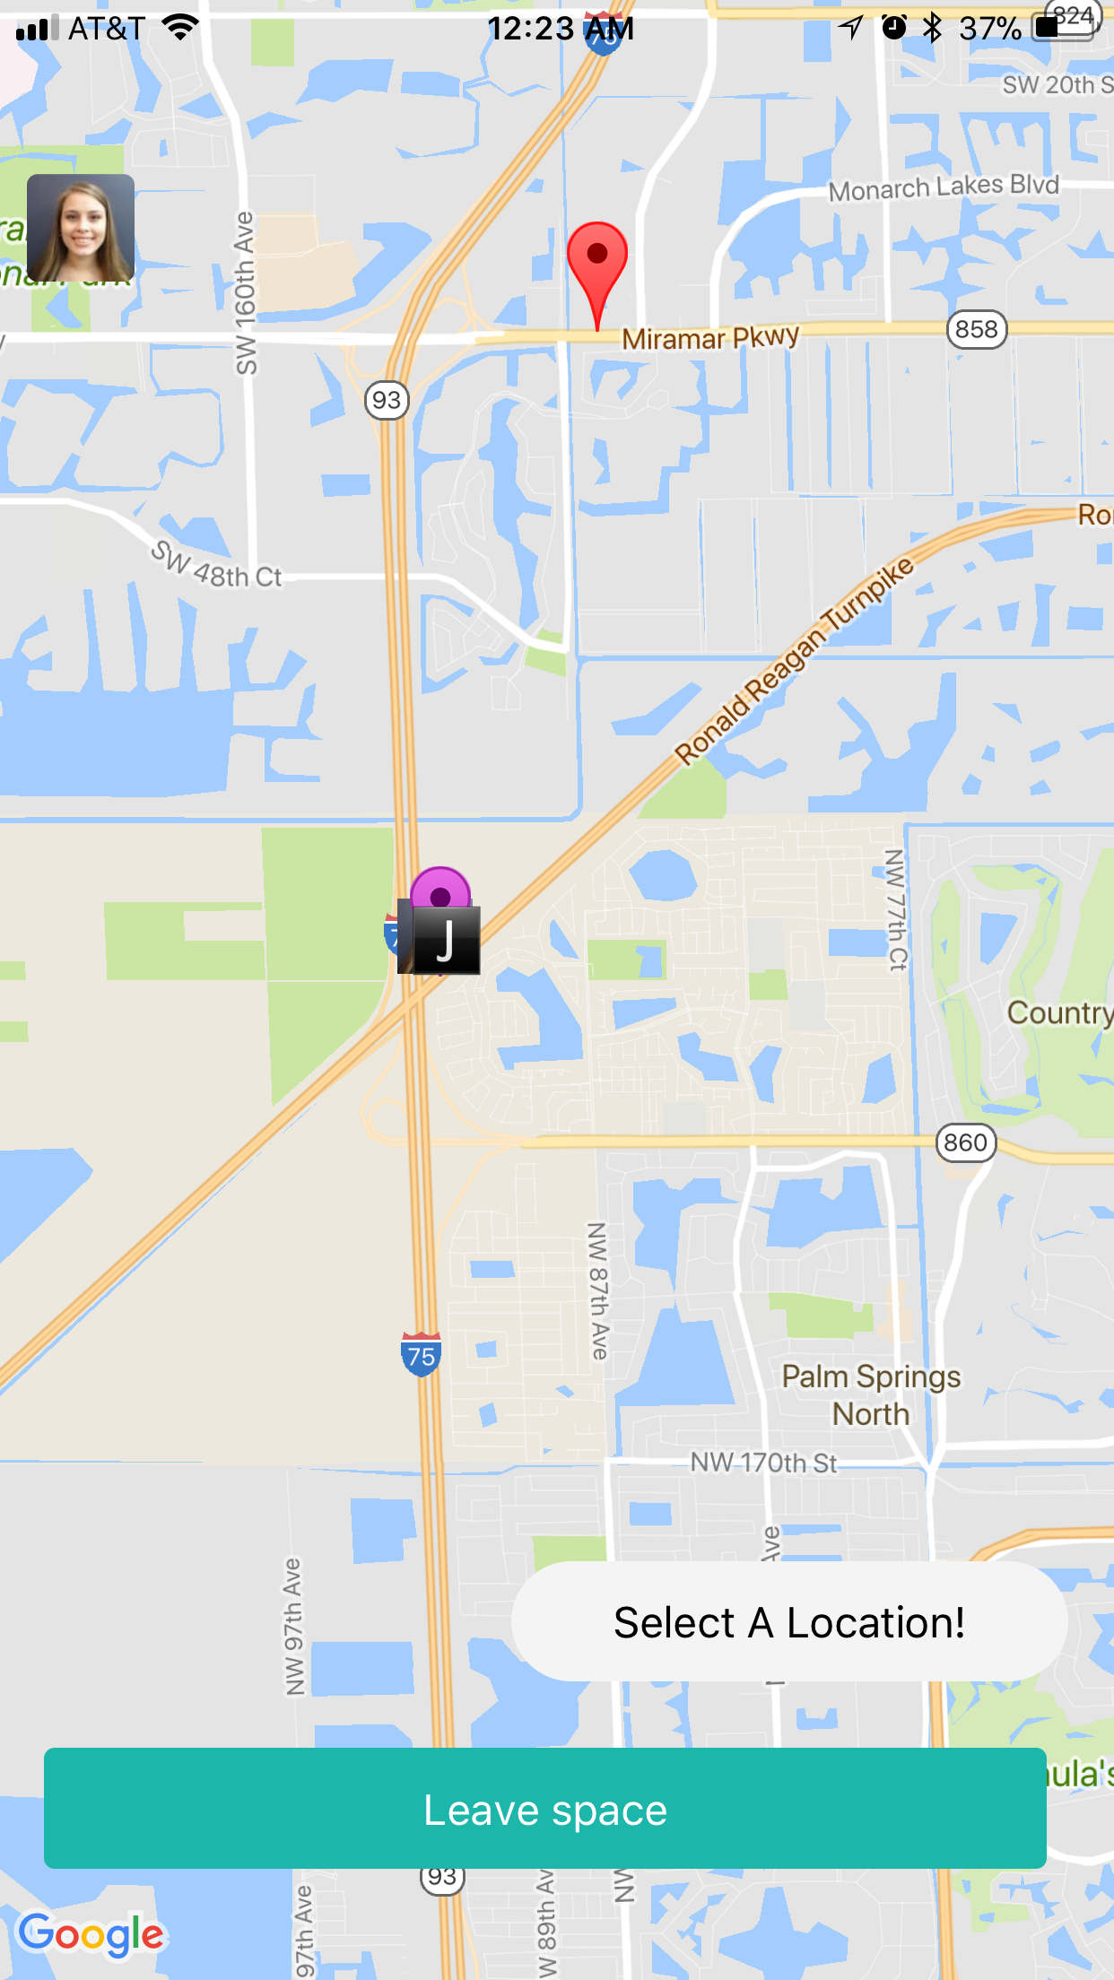

iOS Device

The previous meeting location has been removed and we can now see that the new meeting location has been selected and shown on the map.

**User Story Name: Deep link showing on the phone as an actual link**

* Description: As a user, I want the betwixt like to show as a link, so that I can click it when I receive it

Acceptance Criteria

1. The link must say betwixt.space instead of betwixt.com
2. The link must be clickable

**Use Case**

* Name: Deep linking works when you send the link to another user
* Actor: A virtual employee
* Preconditions: A virtual employee creates a space and sends the invite link to another employee.
* Description <Flow of events>:

1. The virtual employee receives the link

2. The link is clicked

3. The virtual employee is routed to the correct space in the app.

**Use Case Diagram <**you can use draw.io**>**

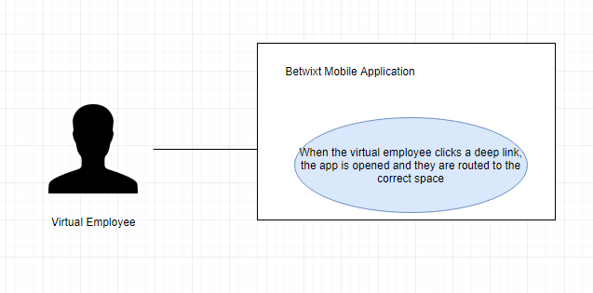

**Sequence Diagram**

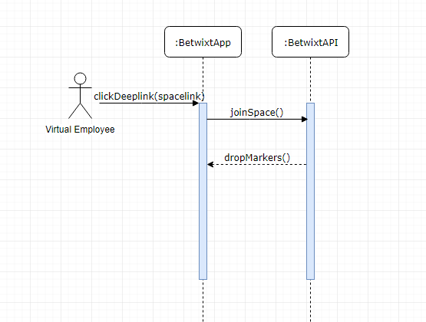

**Class Diagram**

N/A

**Unit Test**

* Test case ID: 001
* Description/Summary of Test: Deep works and routes to the correct group
* Pre-condition: A virtual employee creates a space and sends you an invite link
* Expected Results: You click it and it opens the app and routes you to the correct space
* Actual Result: The app opened and routed to the correct space
* Status (Fail/Pass): Pass

**Integration Test**

N/A

**Visual User Guide** <like one or two screenshots of the feature. For the hardware project, a photo of device is required>

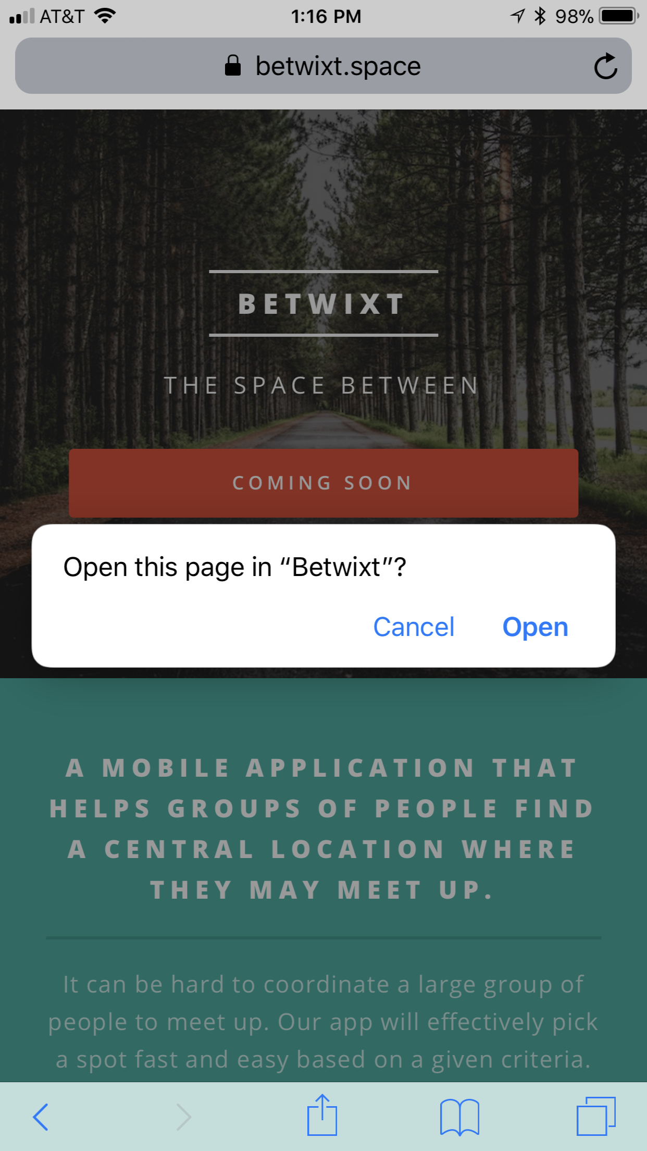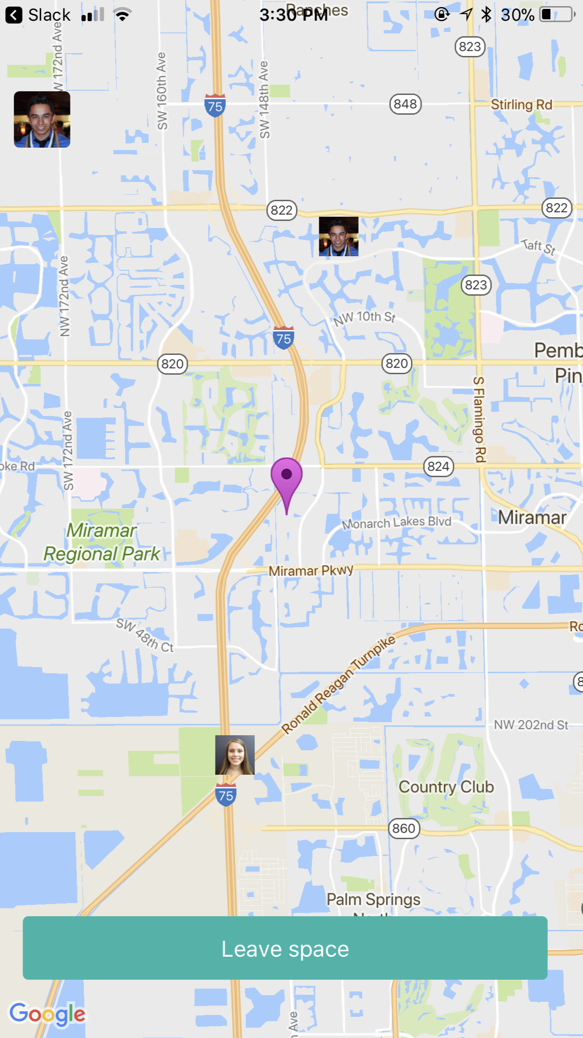

## Pending User Stories

All user stories for the first release were completed.

# Project Plan

This section describes the planning that went into the realization of this project. This project incorporated the agile development techniques and as such required the sprints to be planned. These sprint plannings are detailed in the section. This section also describes the components, both software and hardware, chosen for this project.

## Hardware and Software Resources

The following is a list of all hardware and software resources that were used in this project:

### Software

1. Ionic Framework
2. Angular Framework
3. Express Framework
4. Dokku
5. NPM
6. Workfrom API
7. Geolib package
8. OnWater API
9. Socket.IO
10. Git
11. Xcode
12. Android Studio
13. Cordova and PhoneGap

### Hardware

1. Macbook Pro 13” 16GB 1867 MHz DDR3
2. Windows 10 machine. Intel i5 (4 cores, 3.4GHz). 10 GB of RAM.
3. Macbook Pro 13” 16 GB 1600 MHz DDR3

## Sprints Plan

## August 29, 2017 (Sprint 1)

**Attendees:** Daniel Raad, Joseph Cutrono, Alicia Rodriguez

**Start time:** 4:00pm

**End time:** 5:00pm

After discussion, the velocity of the team were estimated to be **25**.

The product owner chose the following user stories to be done during the next sprint. They are ordered based on their priority.

1. Deploy Boilerplate App #664
2. Deploy Server Side App #665
3. [SPIKE] Research APIs to get locations #666
4. [SPIKE] Research on Authentication Strategy #667
5. [SPIKE] Research on Calculating Central Location #668
6. [SPIKE] Research Phone Geolocation Plugin #669
7. [SPIKE] Research Real-Time Notifications #670

The team members indicated their willingness to work on the following user stories.

* **Alicia Rodriguez**
  + Deploy Boilerplate App #664
  + [SPIKE] Research APIs to get locations #666
  + [SPIKE] Research Phone Geolocation Plugin #669
* **Daniel Raad**
  + Deploy Server Side App #665
  + [SPIKE] Research on Authentication Strategy #667
  + [SPIKE] Research on Calculating Central Location #668
* **Alejandro Palacios**
  + [SPIKE] Research Real-Time Notifications #670

## September 15, 2017 (Sprint 2)

**Attendees:** Alicia Rodriguez, Daniel Raad, Alejandro Palacios, Joseph Cutrono

**Start time:** 5:03pm

**End time:** 5:40pm

After discussion, the velocity of the team were estimated to be **26**.

The product owner chose the following user stories to be done during the next sprint. They are ordered based on their priority.

1. [SPIKE] Research Real-Time Notifications #670
2. Define User Flows #670
3. Create Initial Map View #674
4. Get locations around you #673
5. Display Central Location #676
6. Be able to join a group #677
7. Create Profile #678
8. [SPIKE] Research Ability to Drag a Pin #679

The team members indicated their willingness to work on the following user stories.

* **Alicia Rodriguez**
  + Define User Flows #670
  + Display Central Location #676
  + [SPIKE] Research Ability to Drag a Pin #679
* **Daniel Raad**
  + Get locations around you #673
  + Create Profile #678
* **Alejandro Palacios**
  + [SPIKE] Research Real-Time Notifications #670
  + Create Initial Map View #674
  + Be able to join a group #677

## October 2nd, 2017 (Sprint 3)

**Attendees:** Alicia Rodriguez, Daniel Raad, Alejandro Palacios, Joseph Cutrono

**Start time:** 4:00pm

**End time:** 4:30pm

After discussion, the velocity of the team were estimated to be **19**.

The product owner chose the following user stories to be done during the next sprint. They are ordered based on their priority.

1. Be able to join a group #677
2. Create Profile #678
3. [TECH-DEBT] Resolve Android Issues #680
4. [BUG] Deep Linking Causes Map To Disappear #681
5. [BUG] Not Connecting Users #682

The team members indicated their willingness to work on the following user stories.

* **Alicia Rodriguez**
  + [BUG] Not Connecting Users #682
* **Daniel Raad**
  + Create Profile #678
  + [BUG] Deep Linking Causes Map To Disappear #681
* **Alejandro Palacios**
  + Be able to join a group #677
  + [TECH-DEBT] Resolve Android Issues #680

## 

## 

## 

## October 16, 2017 (Sprint 4)

**Attendees:** Alicia Rodriguez, Daniel Raad, Alejandro Palacios, Joseph Cutrono

**Start time:** 3:47pm

**End time:** 4:06pm

After discussion, the velocity of the team were estimated to be **19**.

The product owner chose the following user stories to be done during the next sprint. They are ordered based on their priority.

1. Show Directions #683
2. Give User Locations To Meet #684
3. Set Preferences As Part Of Creating Space #685
4. What To Do When Central Location On Ocean #686
5. Save Default Preferences On Profile #687
6. Leave A Space (Admin) #689
7. [BUG] The pin of the other users should be dropping for the admin when people are joining the group #688

The team members indicated their willingness to work on the following user stories.

* **Alicia Rodriguez**
  + Give User Locations To Meet #684
  + Save Default Preferences On Profile #687
* **Daniel Raad**
  + What To Do When Central Location On Ocean #686
  + Leave A Space (Admin) #689
* **Alejandro Palacios**
  + Show Directions #683
  + Set Preferences As Part Of Creating Space #685
  + [BUG] The pin of the other users should be dropping for the admin when people are joining the group #688

## October 30, 2017 (Sprint 5)

**Attendees:** Alicia Rodriguez, Daniel Raad, Alejandro Palacios, Joseph Cutrono

**Start time:** 4:21pm

**End time:** 4:45pm

After discussion, the velocity of the team were estimated to be **22**.

The product owner chose the following user stories to be done during the next sprint. They are ordered based on their priority.

1. [TECH-DEBT] Remove Random Coordinates #690
2. Leave Space (Other Users) #694
3. [SPIKE] Research Automated Testing #691
4. [BUG] Admin Pin Not Dropping For Other Users #692
5. Calculate Central Location After Users Have Joined #695
6. User Pins Should Be Their Image #693
7. Admin: Choose A New Location #TBD
8. Make Central Location Always Draggable #696
9. [SPIKE] Research Deep Link Not Showing Up As A Link On Android #TBD
10. [BUG] Profile Picture and Create Space Buttons should Not be on top of google maps default icons #TBD

The team members indicated their willingness to work on the following user stories.

* **Alicia Rodriguez**
  + [TECH-DEBT] Remove Random Coordinates #690
  + [BUG] Admin Pin Not Dropping For Other Users #692
  + User Pins Should Be Their Image #693
* **Daniel Raad**
  + Leave Space (Other Users) #694
  + Make Central Location Always Draggable #696
* **Alejandro Palacios**
  + [SPIKE] Research Automated Testing #691
  + [BUG] Admin Pin Not Dropping For Other Users #692
  + Calculate Central Location After Users Have Joined #695

## November 13, 2017 (Sprint 6)

**Attendees:** Alicia Rodriguez, Daniel Raad, Alejandro Palacios, Joseph Cutrono

**Start time:** 4:15pm

**End time:** 4:45pm

After discussion, the velocity of the team were estimated to be **26**.

The product owner chose the following user stories to be done during the next sprint. They are ordered based on their priority.

1. Calculate Central Location After Users Have Joined #695
2. Admin: Choose A New Location #697
3. [SPIKE] Research Deep Link Not Showing Up As A Link On Android #698
4. [BUG] Profile Picture and Create Space Buttons should Not be on top of google maps default icons #699
5. [BUG] Redirection to location app not working on iOS 11 #700
6. Alicia - Senior Project Poster #701
7. Daniel - Senior Project Poster #702
8. Alejandro - Senior Project Poster #703

The team members indicated their willingness to work on the following user stories.

* **Alicia Rodriguez**
  + Alicia - Senior Project Poster #701
  + Admin: Choose A New Location #697
* **Daniel Raad**
  + Daniel - Senior Project Poster #702
  + [SPIKE] Research Deep Link Not Showing Up As A Link On Android #TBD
* **Alejandro Palacios**
  + Calculate Central Location After Users Have Joined #695
  + Alejandro - Senior Project Poster #703
  + [BUG] Redirection to location app not working on iOS 11 #700

# System Design

This section contains information on the design decisions that went into this project. The architecture patterns are outlined and explained. The entire system is shown in a package diagram and the subsystems are explained. Finally, the design patterns used in the project are discussed.

The Betwixt frontend is built on Ionic 3, Angular 4, Typescript, SASS, and HTML. The server hosted separately is built on NodeJS in Javascript. Our API interfaces the frontend with our server hosted on Dokku and over the HTTPS protocol following RESTful architecture. The client was build using the Component-Based architecture.

## Architectural Patterns

The backend server implements the REST architectural pattern for serving API endpoints in the form of HTTP methods to the client-side application. For communication between clients, a framework called Socket.IO was used to maintain persistent, event-driven communication between the clients. The server functions as a middleman with Socket.IO, relaying information between clients such as a user’s location and a selected location.

## 

## 

## 

## 

## 

## 

## System and Subsystem Decomposition

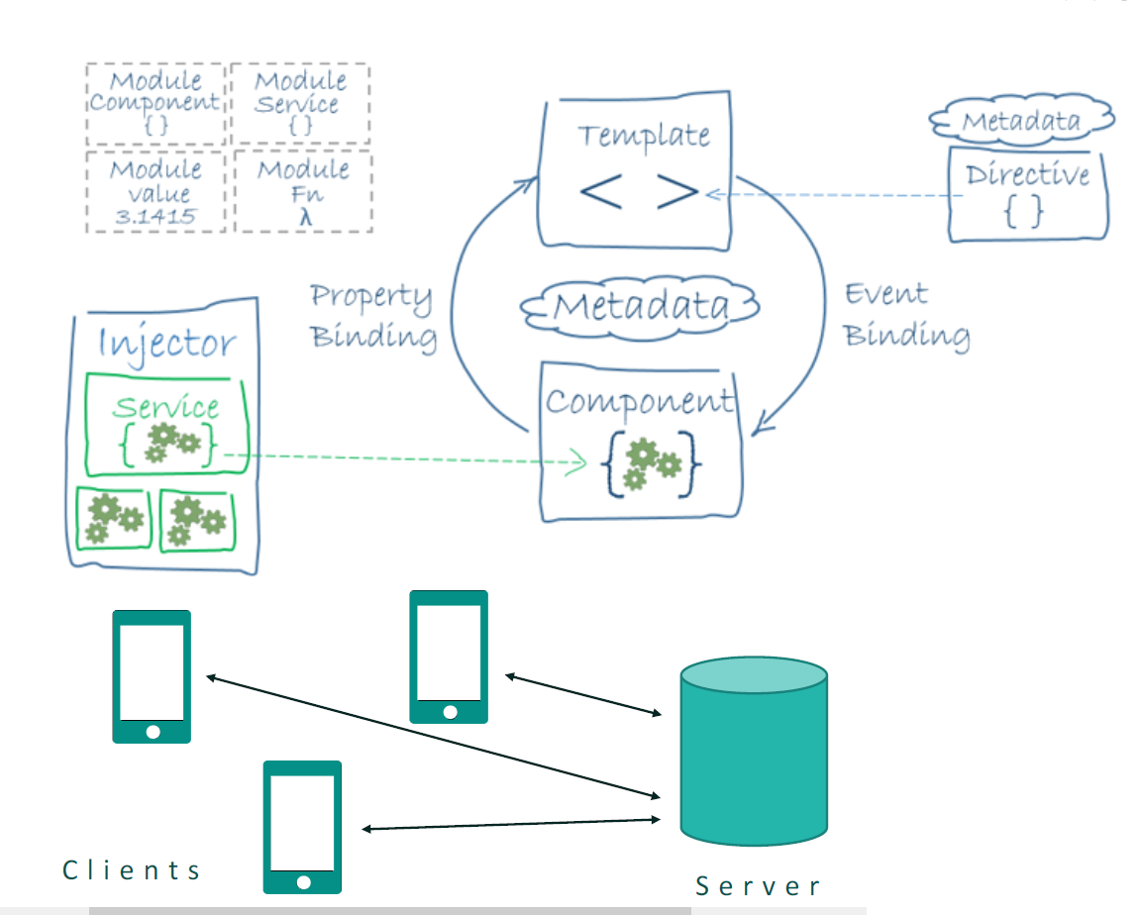

## Deployment Diagram

## 

## Design Patterns

The frontend is structured by different pages of the app. Each page has an HTML file, TS file, and SCSS file. The server is structured by controllers, routes, and sockets folders, each of which have one file at the moment. Most of the functionally is around the sockets and getting the data from the workfrom api to display the locations.

# System Validation

Manual exploratory testing was conducted throughout development. In order to test socket functionality and functionality dependent on socket.IO, a generate user button was added. This button is exclusive to developers and allows the developer to add a random test user within a 10 mile radius of their central location. The test user will send data on their location and receive data about the selected location and the location of others.

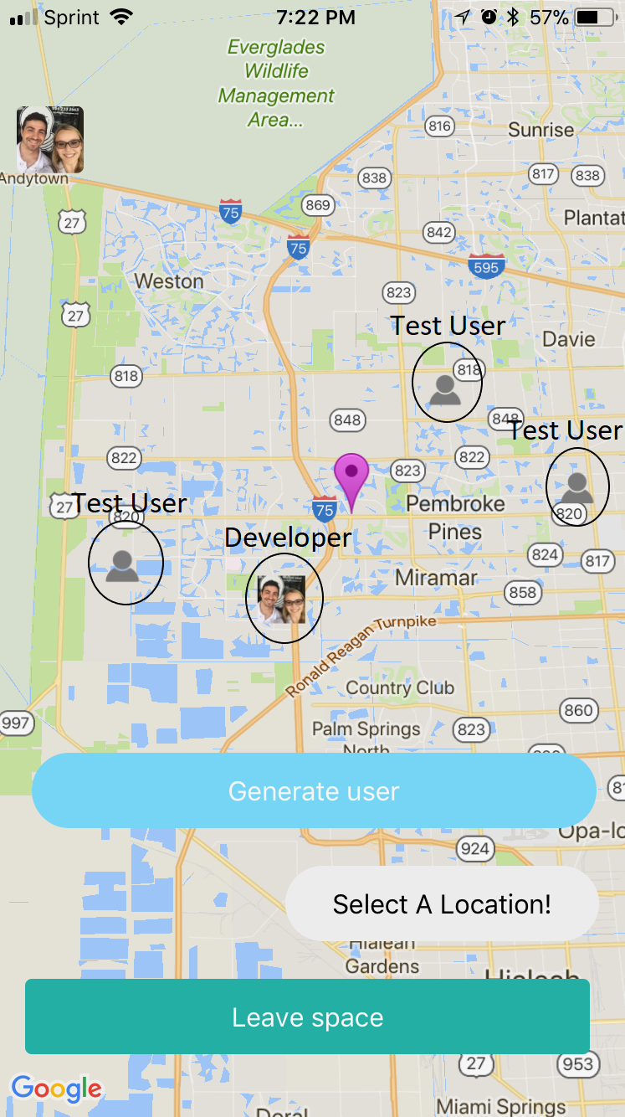

# 

# 

# 

# 

# Glossary

* **Angular:** Angular is a platform that makes it easy to build applications with the web. Angular combines declarative templates, dependency injection, end to end tooling, and integrated best practices to solve development challenges.
* **Socket.IO:** Socket.IO is a JavaScript library for realtime web applications. It enables realtime, bi-directional communication between web clients and servers.
* **TypeScript (TS):** TypeScript is a free and open-source programming language developed and maintained by Microsoft. It is a strict syntactical superset of JavaScript, and adds optional static typing to the language.
* **Workfrom:** API used to retrieve locations that are good for working remotely.

# 

# 

# 

# 

# 

# 

# Appendix

## Appendix A - UML Diagrams

[](https://www.draw.io/#G1Y9mFmxkJM5-zQaUrkb1QI0updK7rFLm0)[](https://www.draw.io/#G1y13_NV33j-X48k7E4ugM0rzhgnuQR7pT)[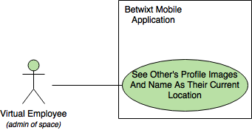](https://www.draw.io/#G1m1W6voXjj6cBiaw5KFIcDT3JWFBcUHgS)[](https://www.draw.io/#G16mrThUUibjWQulmJRpGpTUh8_vJi2OPh)[](https://www.draw.io/#G1Tq-9ADIYBW6eHierM3uP70vIPhVwranx)[](https://www.draw.io/#G1v8awFvZwlkzfcwe8TtODC6u_q4rXh-aM)[](https://www.draw.io/#G1RASbOphXFGxqeA0nErNAiMjm6kPZhTvO)[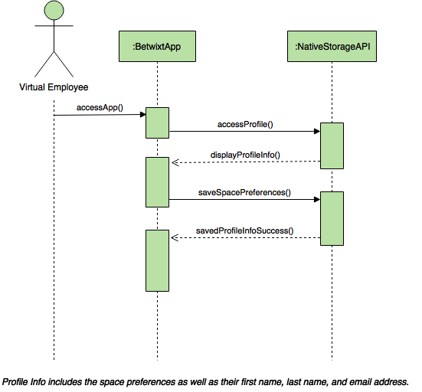](https://www.draw.io/#G0B5wDOQeZQxiaTDllY3BNc0tJUkU)[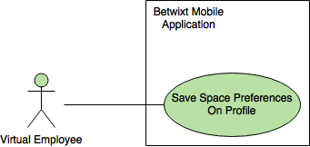](https://www.draw.io/#G0B5wDOQeZQxiaTjdHaTRtdGpkZmc)[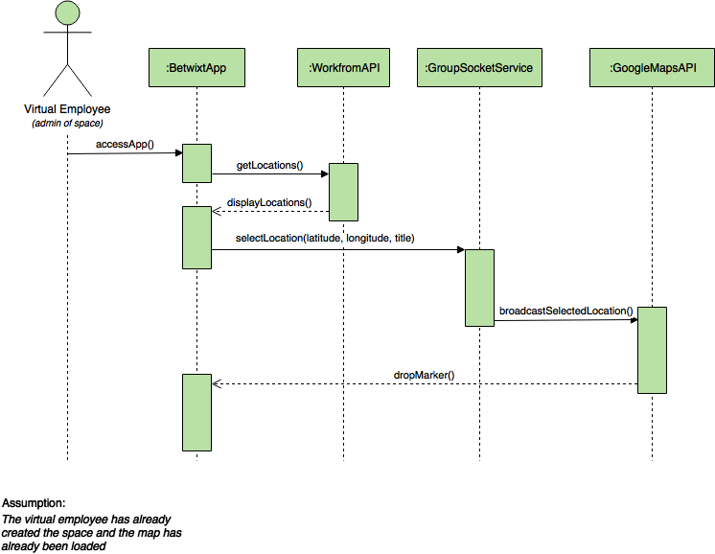](https://www.draw.io/#G0B5wDOQeZQxiaemNHelc0LU16OVk)[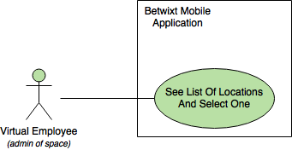](https://www.draw.io/#G0B5wDOQeZQxiaaHY4bDZOMXpUemc)[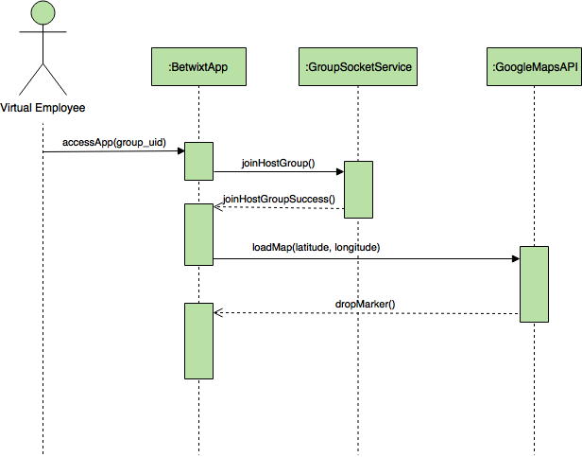](https://www.draw.io/#G0B5wDOQeZQxiaZ2d4b2thYUhlY3c)[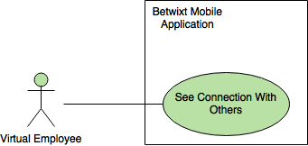](https://www.draw.io/#G0B5wDOQeZQxiaZXFuOXJmd3RDbkU)[](https://www.draw.io/#G0B5wDOQeZQxiaWkxremhOdnFwZ0k)[](https://www.draw.io/#G0B5wDOQeZQxiaU09BTmJ5Rm1IZzQ)

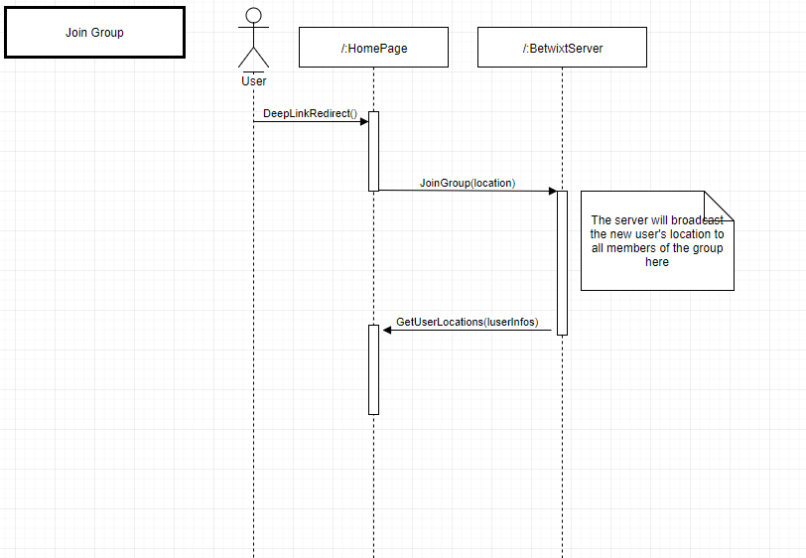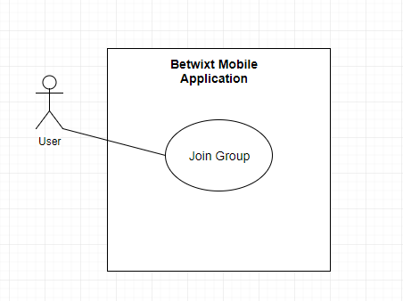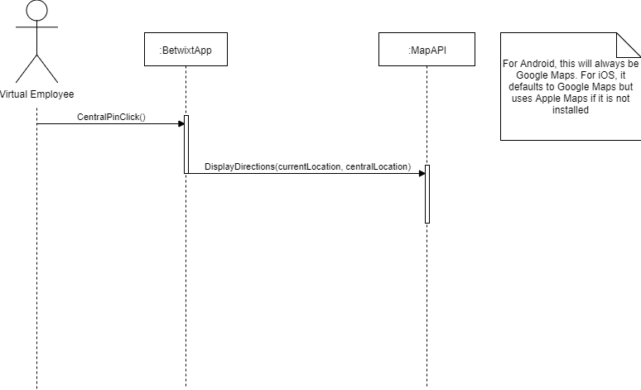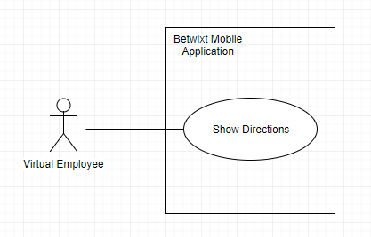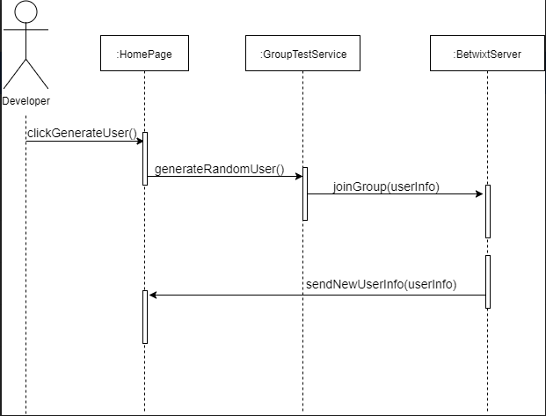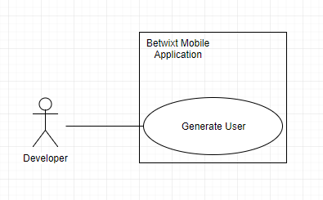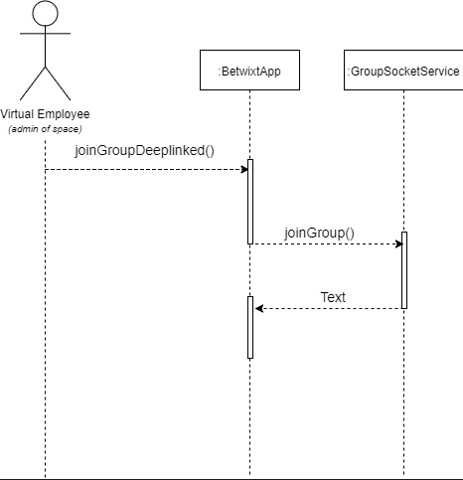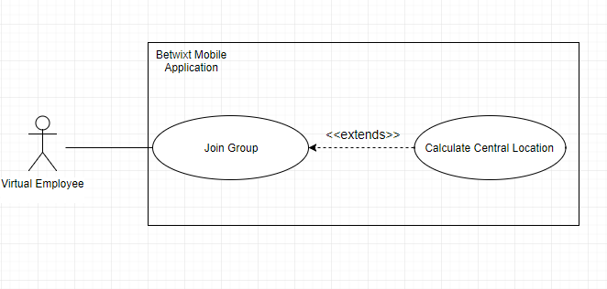

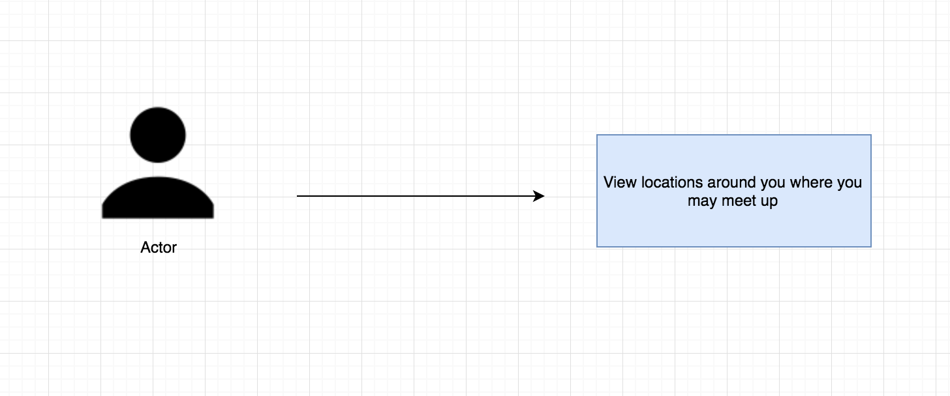

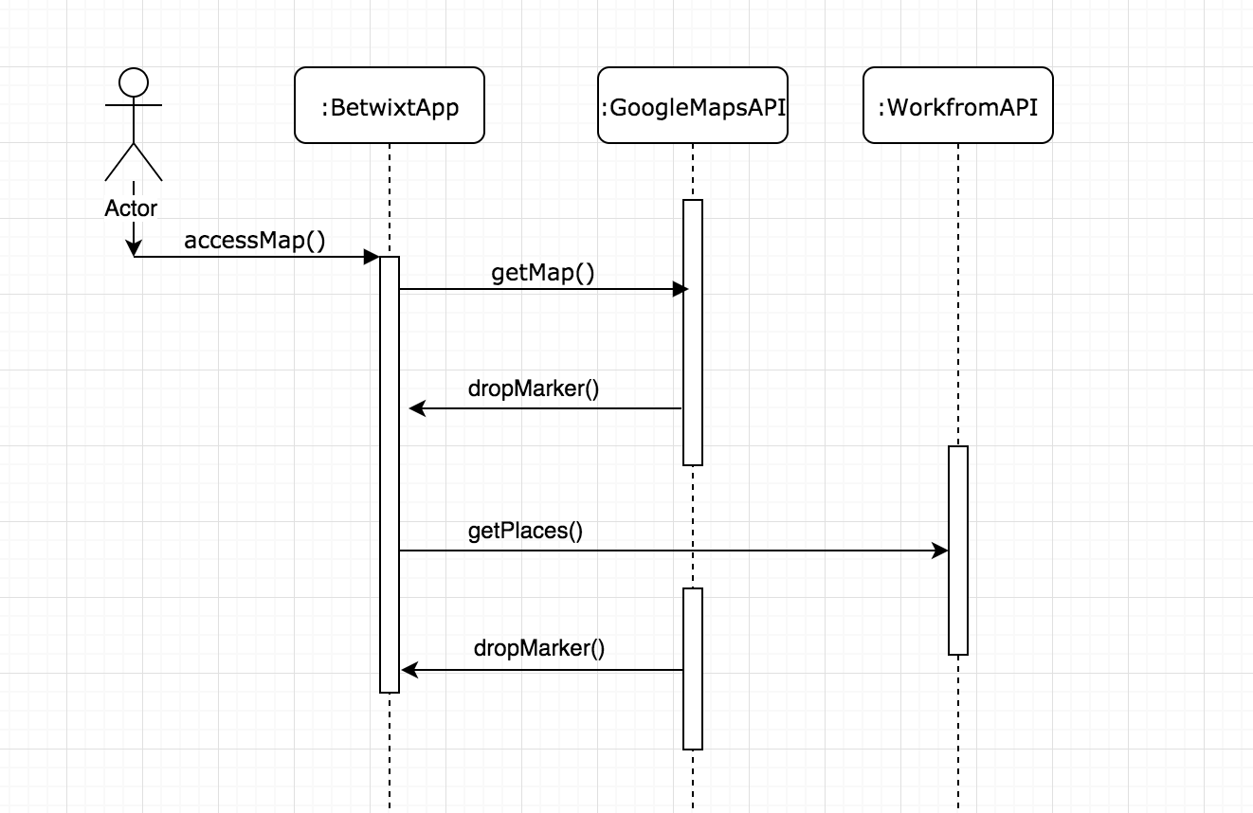

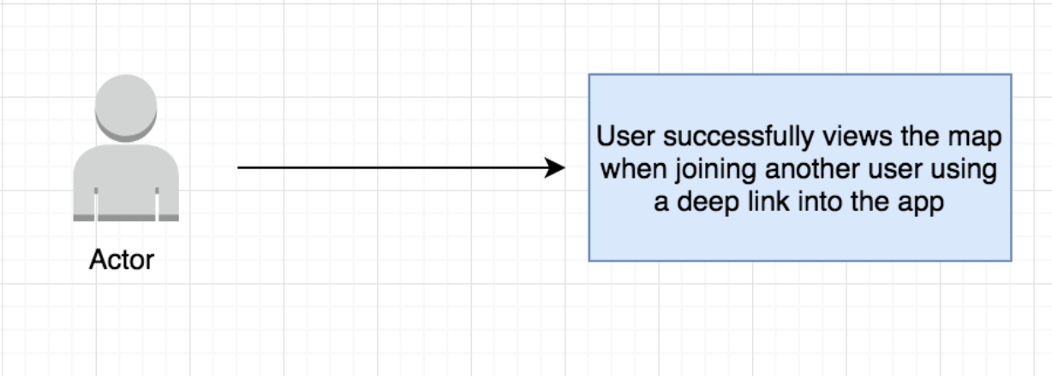

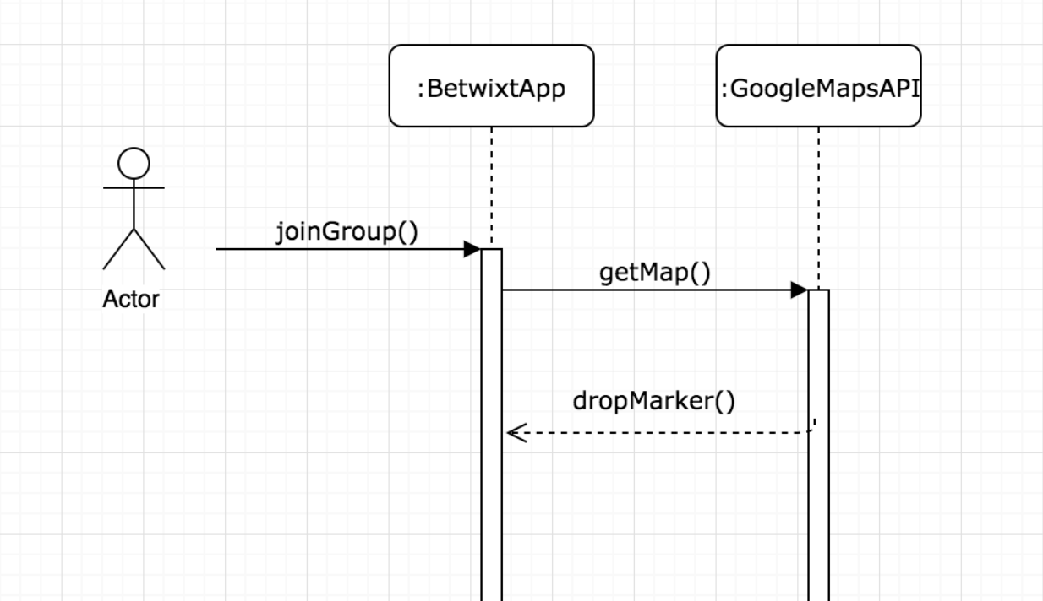













## Appendix B - User Interface Design

## 

## 

## Appendix C - Sprint Review Reports

## September 18, 2017 (Sprint 1)

**Attendees:** Joseph Cutrono, Alicia Rodriguez, Alejandro Palacios, Daniel Raad

**Start time:** 4:00pm

**End time:** 4:34pm

After a show and tell presentation, the implementation of the following user stories were accepted by the product owners:

1. Deploy Boilerplate App #664
2. Deploy Server Side App #665
3. Research APIs to get locations #666
4. Research on Authentication Strategy #667
5. Research on Calculating Central Location #668
6. Research Phone Geolocation Plugin #669

The following ones were rejected and moved back to the product backlog to be assigned to a future sprint at a future Spring Planning meeting.

1. Research Real-Time Notifications #670

## October 2nd, 2017 (Sprint 2)

**Attendees:** Joseph Cutrono, Alicia Rodriguez, Alejandro Palacios, Daniel Raad

**Start time:** 3:15pm

**End time:** 3:39pm

After a show and tell presentation, the implementation of the following user stories were accepted by the product owners:

1. Research Real-Time Notifications #670
2. Define User Flows #670
3. Create Initial Map View #674
4. Get locations around you #673
5. Display Central Location #676
6. Research Ability to Drag a Pin #679

The following ones were rejected and moved back to the product backlog to be assigned to a future sprint at a future Spring Planning meeting.

1. Be able to join a group #677
2. Create Profile #678

## October 16, 2017 (Sprint 3)

**Attendees:** Joseph Cutrono, Alicia Rodriguez, Alejandro Palacios, Daniel Raad

**Start time:** 3:15pm

**End time:** 3:32pm

After a show and tell presentation, the implementation of the following user stories were accepted by the product owners:

1. Be able to join a group #677
2. Create Profile #678
3. [TECH-DEBT] Resolve Android Issues #680
4. [BUG] Deep Linking Causes Map To Disappear #681
5. [BUG] Not Connecting Users #682

## October 30, 2017 (Sprint 4)

**Attendees:** Joseph Cutrono, Alicia Rodriguez, Alejandro Palacios, Daniel Raad

**Start time:** 3:15pm

**End time:** 3:51pm

After a show and tell presentation, the implementation of the following user stories were accepted by the product owners:

1. Show Directions #683
2. Give User Locations To Meet #684
3. Set Preferences As Part Of Creating Space #685
4. What To Do When Central Location On Ocean #686
5. Save Default Preferences On Profile #687
6. Leave A Space (Admin) #689
7. [BUG] The pin of the other users should be dropping for the admin when people are joining the group #688

## November 13, 2017 (Sprint 5)

**Attendees:** Joseph Cutrono, Alicia Rodriguez, Alejandro Palacios, Daniel Raad

**Start time:** 3:15pm

**End time:** 3:45pm

After a show and tell presentation, the implementation of the following user stories were accepted by the product owners:

1. [TECH-DEBT] Remove Random Coordinates #690
2. Leave Space (Other Users) #694
3. [SPIKE] Research Automated Testing #691
4. [BUG] Admin Pin Not Dropping For Other Users #692
5. User Pins Should Be Their Image #693
6. Make Central Location Always Draggable #696

The following ones were rejected and moved back to the product backlog to be assigned to a future sprint at a future Spring Planning meeting.

1. Calculate Central Location After Users Have Joined #695
2. Admin: Choose A New Location #697
3. [SPIKE] Research Deep Link Not Showing Up As A Link On Android #698
4. [BUG] Profile Picture and Create Space Buttons should Not be on top of google maps default icons #699

## November 27, 2017 (Sprint 6)

**Attendees:** Joseph Cutrono, Alicia Rodriguez, Alejandro Palacios, Daniel Raad

**Start time:** 2:00pm

**End time:** 2:30pm

After a show and tell presentation, the implementation of the following user stories were accepted by the product owners:

1. Calculate Central Location After Users Have Joined #695
2. Admin: Choose A New Location #697
3. [SPIKE] Research Deep Link Not Showing Up As A Link On Android #698
4. [BUG] Profile Picture and Create Space Buttons should Not be on top of google maps default icons #699
5. [BUG] Redirection to location app not working on iOS 11 #700
6. Alicia - Senior Project Poster #701
7. Daniel - Senior Project Poster #702
8. Alejandro - Senior Project Poster #703

## Appendix D - User Manuals, Installation/Maintenance Document, Shortcomings/Wishlist Document and other documents

## Videos

Playlist of the videos: https://www.youtube.com/playlist?list=PLG3lylzOg8FinZFpAWzs6L2tgzbVnhcKM

### Introduction Video

<https://youtu.be/3Vn2bCd7Gto>

### Virtual Employee (Admin) User Guide

<https://youtu.be/Y3YkNsDO4ww>

### Virtual Employee User Guide

<https://youtu.be/2Rze5QYSPGw>

### Installation & Maintenance Guide

<https://youtu.be/PxpUwauQnec>

### 

### Shortcomings & Wishlist

<https://youtu.be/SaOS_6Def34>

## Posters

Posters can be found in the Posters folder.